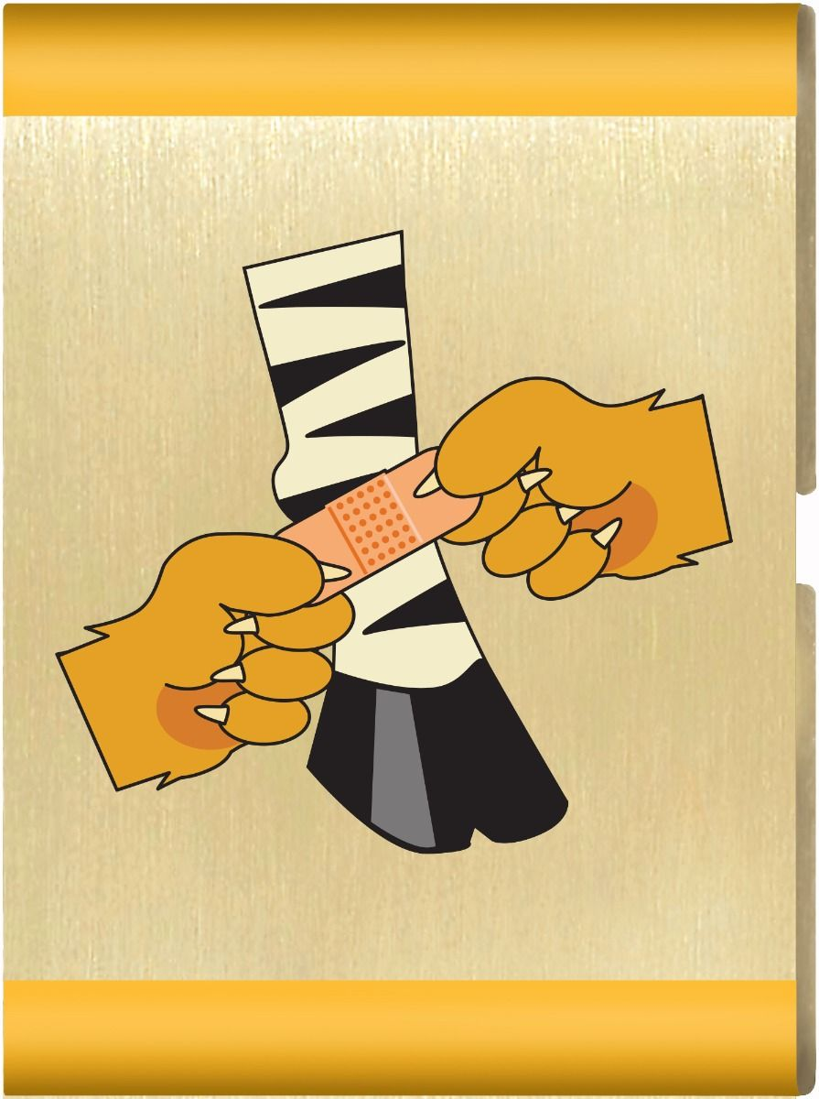
Animal Kingdom Adventure
Materials List

Parent and Leader Guidebook: pages 32-35
Lion Adventure Book: page 6
- Learn the role of someone who provides a service to your community.
- Demonstrate you know what to do in an emergency.
- Choose two energy saving projects to practice in your home for two weeks.
- Participate in a Lion den family service project for others.

Visitor: Police officer, firefighter, veteran, paramedic, or EMT

Materials
- Copies of Animal Kingdom handout, one per adult
- Copy of Den Meeting Plan, one for leader(s)
- Name tags and Sharpie
- Copies of pack calendar
- Cub Scouts Poster Set with Scout Law, Scout Oath and Den Code of Conduct
(#621086 from Scout Shop)
- Blue tape or something to hang posters on wall

Optional
- Snack and water
- Activities for siblings (e.g., coloring books)

Activity 1: Visitor
- Police officer, firefighter, veteran, paramedic, or EMT

Activity 2: Emergency Preparedness Game
- Copy of Parent and Leader Guidebook, page 35
- Adhesive bandages (scraped knee, cut)
- Cloth or bandanna (nosebleed)
- Small plastic bag with word “ice” on a slip of paper inside (bug sting, sprained ankle)
- Cell phone (bug sing, bump on head, broken arm)
- Soap (scraped knee, cut)
- Moleskin and scissors (blister on foot)

Wrap Up Game
- Colored pencils, crayons or markers
- Few extra copies of Lion Adventure Book page 6 (for those who forget book).

Supplemental, optional (can be sent home if meeting runs long)
- Copies of Helpful vs. Hurtful
Den Meeting Plan
Animal Kingdom

Parent and Leader Guidebook: pages 32-35
Lion Adventure Book: page 6
- Learn the role of someone who provides a service to your community.
- Demonstrate you know what to do in an emergency.
- Choose two energy saving projects to practice in your home for two weeks.
- Participate in a Lion den family service project for others.

Gathering
- Game of Tag
Opening
- Good conduct candle
- Pledge, Scout Oath, Scout Law
- Give a big Lion Roar!
Talk Time
- Lions live in groups called prides. They work together for food and to protect each other. Just as Lions watch over the pride, this week, you will be watching over your homes to help save energy for the next two weeks to help conserve.
- There are simple ways that Scouts can have a significant impact on the environment. Although the actions may seem small and insignificant on an individual level, by working together we can have a big impact.
- Only one percent of the Earth's water resources are useable for drinking - the rest is permanently frozen or salt water. It is critical that everyone conserve water all the time.
- Simple habits can lead to big savings for the environment and for your parents. Turning off the lights when leaving any room and leaving the door open only long enough to go through it is a great place to start!
- Den business
- Sharing time
Activities
- Activity 1: Visitor
- Activity 2: Emergency Preparedness Game
- Activity Wrap-up: Lion Adventure Book, page 6
Closing
- Scout Law
- Reflect on “A Scout is Helpful.” Tie “helpful” back to the community visitor.
Animal Kingdom Adventure
Homework:

Watch over your home to help save energy and water for the next two weeks (e.g., turn off water while brushing teeth, turn off lights when leaving a room).

Scout Law
A Scout is trustworthy, loyal, helpful, friendly, courteous, kind, obedient, cheerful, thrifty, brave, clean, reverent.
Scout Oath
On my honor, I will do my best to do my duty to God and my country and to obey the Scout Law; to help other people at all times; to keep myself physically strong, mentally awake, and morally straight.
Upcoming Events

Dec 20 Pack Meeting
(bring food to donate)

Jan 10 Den Meeting
TBD Outing

Feb 7 Den Meeting
Feb 24 Pinewood Derby
Feb 28 Pack Meeting

Mar 7 Den Meeting
TBD Outstanding
14 Family Campout
Pack 72
facebook.com/pack72tomball
pack72tomball.scoutlander.com
Orion District
www.orion.shac.org
facebook.com/orionbsa
Sam Houston Area Council
www.shac.org
facebook.com/shac.bsa

Helpful | Hurtful

On | 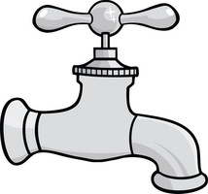  On | Closed | Closed
Off | 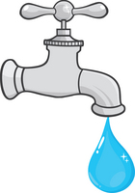  Off | Open | Open

