Fire Fighter Theme

www.shac.org/fire-theme

Cub Scouts learn how to be safe, be prepared for emergencies, and react to emergencies! Teach Cub Scout how to use the buddy system and take the opportunity to explain its importance. Cub Scouts can explore how to be helpful by avoiding accidents and being prepared for emergencies. Use games and/or mock accidents so Cub Scouts can show they can help by com to the rescue.
Tigers learn to prepare for emergencies while working on the Safe and Smart Adventure. While visiting with the fire department, Wolves can work on the Council Fire Adventure and Bears can work on the Paws For Action. Wolves learn how to be careful with fire while working on the Call of the Wild Adventure and Call of the Wild Adventure. Webelos Scouts learn about what actions to take in extreme weather Outdoorsman / Camper Adventure and the proper way to build a fire while working on the Castaway and Cast Iron Chef Adventures.
A fire fighter theme makes a great theme for pack meetings, or banquets.

- Pack Meetings: The pack meeting brings all the dens in the pack together for the purposes of recognizing the achievements of the Cub Scouts, communicating information about upcoming events, and providing a program that enriches the Cub Scouting experience. It helps the Cub Scouts realize their den is part of a larger organization. A good pack meeting should be well planned and well organized. Packs meet several times during the year – there is no required number.
- Banquets: Most packs celebrate Scouting Anniversary Week in February with a birthday party called the blue and gold banquet; some packs do end of the year banquets.
Content  (Sources: Baloo’s Bugle: To the Rescue (Oct 2005) and To the Rescue (Sept 2016); BSA To The Rescue (Sept 2016)  Sample Meeting  Program Agenda Page 4  Podium Script Page 5  Cheers Page 31  Pack Meeting or Banquet Handout Page 34  Additional ideas  Advancement Ceremonies Page 40  Audience Participation Page 42  Closing Ceremonies Page 43  Cubmaster Minute Page 45  Den and Pack Activities Page  Games Page 45  Gathering Activities Page 51  Invocation Page 52  Opening Ceremonies Page 71  Skits Page 72  Songs Page 73  Stunts & Jokes Page 77  Theme Related Stuff Page 78  Activity Pages Coming soon  Placemats shac.org/fire-theme | Placemats  Coming Soon  Free, customizable placemats are available for packs to use at banquets or den meetings to help promote day camp. Download the placemats at www.shac.org/fire-theme.
Pinterest
Find additional ideas on the SHAC Pinterest page: www.pinterest.com/samhoustonbsa

ABOUT PACK MEETINGS

Before the Meeting prepare all materials and notify each person responsible for a part of the program. Plan to arrange the room (e.g., chairs, tables, flags, sound system) and set up equipment, materials (e.g., advancements) and props with plenty of time to spare so the meeting can start on time.

Gathering (optional). As the Cub Scouts begin to arrive, they join in an informal activity (e.g., activity sheet) or game, often conducted by the den chief to keep everyone interested and active until the entire group has arrived. The gathering activity must be done prior to the formal start of the meeting as it encourages everyone to arrive on time so the meeting can start on time. Consider assigning greeters at the door to welcome Cub Scouts, guests, and families to the pack meeting. Find gathering activities here.

Welcome: The Cubmaster welcomes everyone to the pack meeting and makes any necessary introductions.

Opening: The opening ceremony is the official start to the meeting and sets the stage. It can reinforce the purpose of Scouting and help make the Scouting ideals meaningful through the words and pictures of the ceremony. One of the points of the Scout Law can be highlighted each month. Be award of physical and/or mental disability challenges. Be sensitive that not all youth may be able to read or talk in front of a group. Adapt ceremonies in a sensitive way to involve everyone at the level they will feel comfortably involved. Pre-select a den to lead the opening ceremony and have the den leader practice with the Scouts for several meetings prior. Have posters with a picture on one side and the script printed with large letters on the back. Teach the Scouts how to talk with their head up and project their voice to the people in the back of the room. Find opening ceremonies here and in the Cub Scout Ceremonies for Dens and Packs, No. 33212.

Flag Ceremony: Pre-select a den to lead the pledge and have the den leader practice flag etiquette with the Scouts for several meetings prior. The same den that conducted the opening can also conduct the opening ceremony. Consider group recitation of the Scout Law, Scout Oath and Outdoor Code after the pledge. The pocket guide can assist the Scouts: https://shac.org/Data/Sites/1/media/instep/flag-ceremony.pdf.

Invocation. Find invocations here.

Program The pack meetings, the program is reserved for dens who have requirements for adventures to share or demonstrate something they have learned. This can also be used as a time a song or skit.

For blue and gold banquets, the pack committee may decide to bring in an entertainer such as a scientist or magician and have a video or slide show of what the pack did over the past year. Each unit is requested to hold a Friends of Scouting (FOS) presentation typically at the blue and gold banquet. The presentation, which takes approximately seven minutes to conduct, informs parents and leaders of all council services, its financial needs and extends an opportunity to help fulfill the need. The FOS campaign is a vital component to the programs and services of the council. The money offsets cost of training leaders, operating camps, and the service center, as well as providing other resources to units in the council.

Songs. Singing builds pack spirit and enthusiasm. Singing gives Cub Scouts a chance to let off steam. Singing is fun! Use a song or two to set the mood for meetings, to get the audience moving and get rid of those wiggles or to quiet and calm the group when it’s time to go. Have a few songs ready to use as fillers during transition times. Pre-select a den to lead a song in the meeting handout. Songs can be found here and in the Cub Scout Leader How-To Book, No. 33832 and Cub Scout Songbook, No. 33222.

Leader Recognition (for banquets and other meetings as appropriate). When working with volunteers, thanks is the only payment we can really give them. Public recognition is the most valued form of payback for volunteers – so remember to recognize parents, leaders and others who help the program! Consider a hand written thank you note, homemade award, certificate of appreciation, or gift from the Scout Shop. Consider submitting pack leaders for adult awards and recognitions (e.g., training awards) or district awards that they qualify for and presenting them at the blue and gold banquet. Find leader recognition ceremonies here.

Skits (optional). Skits appeal to Cub Scouts. Acting comes naturally to many Cub Scouts, and help channel youth imagination. Skits give a chance for creative expression, gaining self-cofidence, and teamwork and coopration. Some shy kids many not want to take part in skits and might be give responsibilities for handling props or “directing.” Have a den leader select a skit and practice for several meetings prior. Skits can also be found in the Cub Scout Leader How-To Book, No. 33832. The Cub Scouts should be taught how to talk clearly, slowly, loudly and to the back row of the audience (or speaking into the microphone correctly).

Run-ons are similar to skits but are much shorter and require only one or two people. Run-ons are good for a change of pace during pack meetings and campfires – something to make everyone laugh and relax. They come in handy as fill-ins between acts to fill dead time or to enliven the program.

Audience Participation (optional) stories add variety, action and fun to pack meetings. Some include motions. Some require the adience be dived into groups that respond to a key word in a story read by a a leader. It’s a good idea to let groups practice their motions or phrases first. Find participation skits here and the Cub Scout Leader How-To Book, No. 33832.

Advancement Ceremony. Recognition is important to Cub Scouts. Each one represents a great amount of time and effort on the part of the Cub Scout, family, and leaders and should be presented in a special ceremony. The presentation should be worthy of the award and the work that went into it. When Cub Scouts are recognized for their accomplishments, they are motivated to achieve more. Memories of meaningful, impressive ceremonies will last years. Depending on the advancements that you have for each month’s pack meeting, you’ll need to adapt ceremonies. Delete sections that relates to a badge that you are not presenting or change that section to a narrative form in place of the badge presentation. Use your imagination to make the ceremonies work for you. A variety of leaders can be involved in the advancement ceremony (e.g., advancement chair, Cubmaster, assistant Cubmasters, den leaders, den chiefs). Use simple props and costumes to enhance ceremonies. Some ceremonies will be simple (monthly awards) while others are more involved (e.g., rank ceremonies, crossover ceremonies, Arrow of Light ceremonies). Find advancement ceremonies here and in the Cub Scout Den and Pack Ceremonies, No. 33212.

Games (optional). Are part of the fund of Scout Scouting and can help youth develop self-conficence, independence and the ability to get a long with others. Games teach youth to follow rules, take turns, responsibt the rights of others, to give and take and to play fair. Games can be effective during pack meetings as long as the meeting doesn’t run too long. Consider the physical aspect, age of the youth, space requirements, time requirements, equipment, skills and abilities, number of players needed, equipment and purpose (physical, mental, educational). Games can be found a here and in the Cub Scout Leader How-To Book, No. 33832 has a whole section on cooperative games.

Announcements. Announcements should be kept very short. Announcement details (e.g., date, time, address, description of event, who can attend, what to bring, web page to find more information) should be provided in pack meeting handout. The Cubmaster should take only about one minute to enthusiastically highlight the exciting upcoming activities and then let adults to read about in their pack meeting handout.

Cubmater Minute. At the end of a pack meeting filled with learning, fun, and fellowship comes the grand finale, the Cubmaster Minute. Consider it a closing argument to your Scouts — one last chance to inspire before they head home. Find a message that’s relevant, powerful, and memorable that can be crammed into 60 seconds. It’s an opportunity to quiet the Cub Scouts and put them in a reflective mood before departing. Find Cubmaster Minutes here.

Closing: the closing ceremony is draws the meeting to an end. It’s usually serious and quiet and provides an opportunity to present a brief character lesson, a simple thought. Keep it simple.

Cheers. Silly cheers and applauses are a great way to recognize Scouts and Scouters at den or pack meetings for accomplishments and performances. Cheers and applauses add fun to den meetings, pack meetings, and campfire programs.

After the Meeting. The leaders review the events of the meeting, finalize plans for the next pack meeting, and review their progress toward the upcoming pack meeting.

Resources:
- Pack Meeting Resources: www.shac.org/pack-meetings
- BSA Pack Meeting Resources: www.scouting.org/programs/cub-scouts/pack-meeting-resources
- Pack Meeting Tips: https://blog.scoutingmagazine.org/2018/12/10/8-essential-tips-for-controlling-chaos-at-cub-scout-pack-or-den-meetings/

PACK MEETING PLANNING SHEET

Pack Meeting Date: |  | Theme: | Creepy Critters

Time | Activity | Materials | Responsible
6:30 pm | Before the meeting | - set up chairs  - sound system  - flags  - advancement table
6:45 pm | Gathering | - activity sheet  - pencils  - pack meeting handouts | - (greeters)
7:00 pm | Welcome | - safari hat | - Cubmaster
7:01 pm | Opening: Hometown Heroes  # 1: Sometimes a local hero is obvious, the policeman who risks their life to protect us from violence or the fireman who pulls people out of burning buildings.  # 2: Other heroes that come to mind are the ambulance drivers, paramedics, doctors and nurses who save lives everyday.  # 3: Some people around us seem like regular people, but they are heroes because they used to be soldiers in the military and served our country to keep us free.  # 4: A hero is someone who does the right thing even when they are afraid of failure. They do it because it should be done.  # 5: Some heroes are harder to spot, but they are still there. My heroes include the people who donate blood, teachers who spend their time and energy helping kids, and kids who say “No” to drugs.  # 6: Heroes are all around us. Please join in saluting all the heroes of our country, by repeating with me the Pledge of Allegiance to the Flag. | - 6 Cub Scouts  - Posters with script on back  - cheer box  - printed cheers | - ___ Den  - den leader
7:03 | Flag Ceremony | - 2+ Cub Scouts  - flags  - pocket guide | - ___ Den  - den leader  - assistant Cubmaster (leads cheer)
7:06 | Invocation  Thank you for our leaders who teach us what to do in an emergency and for the willingness to be helpful to others. | - printed script
7:08 | Program |  | - ___ Den  - den leader
7:15 | Song  List on pack meeting handout | - pack meeting handout | - ___ Den  - den leader
 | Leader Recognition (if applicable) | - printed script  - recognition items | - committee chair  - Cubmaster (assists)
7:17 | Skit (optional) |  | - ___ Den  - den leader  - assistant Cubmaster (leads cheer)
 | Audience Participation (optional) | - printed script | - Cubmaster  - assistant Cubmaster (leads cheer)
 | Game (optional, if time permits) |  | - Cubmaster  - assistant Cubmaster (leads cheer)

7:20 | Advancement Ceremony  As Cub Scouts we must be aware of being fire safe. As we develop in Scouting, our knowledge increases, our awareness of safety protects ourselves and those who live, play and work with us. Our responsibility to be fire safe and guide others increases as time goes on. Cub Scouts also learn how to take care of themselves and how to give first aid. They learn to stay calm, Be Prepared, and to do their best to be helpful in an emergency. While hoping they never have to, our Cub Scouts know how to come to the rescue.  “Lions are introduced to the Scout Law, which teaches us that a Scout is helpful and can come to the rescue when needed. Lions also demonstrated what to do in an emergency. Would the Lions please come forward with their parents or guardians? (Present awards and lead cheer).  “Tigers learned to come to the rescue by staying calm and asking for help when in an emergency. Tiger learned how to be safe and smart, how to Stop, Drop and Roll, how to plan an escape route from their home, and check the smoke detectors. Would the Tigers please come forward with their parents or guardians? (Present awards and lead cheer).  “Advancing in knowledge are Wolves. Wolves have learned about outdoor fire safety for a campfire, and how to come to the rescue by having a plan and being prepared for emergencies. Would the Wolves please come forward with their parents or guardians? (Present awards and lead cheer).  “Bears learn how to come to the rescue by avoiding accidents with knives and while camping. They learned about cooking and cooking safety, what to do for burns, and how to safely cook a foil pack over a fire. Would the Bears please come forward with their parents or guardians? (Present awards and lead cheer).  “The fourth grade Webelos Scouts have increased their knowledge of fires and fire safety and learned even more outdoor fire safety learn how to come to the rescue of others by being a first responder. Would the fourth grade Webelos Scouts please come forward with their parents or guardians? (Present awards and lead cheer).  “Our fifth grade Webelos Scouts learn to come to the rescue of our world. They have built fires, maintained them safely, and, used them for cooking. They have learned what to do if a fire is in their campsite. And how to light a fire without matches. Would the fifth grade Webelos Scouts please come forward with their parents or guardians? (Present awards and lead cheer). | - awards  - printed script  - cheer box  - printed cheers | - advancement chair  - Cubmaster  - assistant Cubmaster (assists; leads cheer)
7:50 | Song  List on pack meeting handout | - pack meeting handout | - ___ Den  - den leader
7:53 | Announcements | - printed script  - pack meeting handout | - Cubmaster
7:55 | Cubmaster Minute: Be Prepared  Being a hero does not mean that you must risk your own life. It can mean getting help, or making a phone call to 911 to get the police, or fire department, or ambulance. The key is to use wisdom and judgment, but to do it quickly. Sometimes time is limited. You can save a drowning person by pulling them in with a life ring, and not become a victim yourself by jumping in after them. Many times an adult’s life has been saved because a child knew to call 911 in an emergency and get help right away. You never know when or where emergencies will arise. Cub Scouting teaches us to handle these situations. We don’t expect to get hurt, and don’t expect to need first aid, but we are prepared just in case. Do Your Best! | - printed script | - Cubmaster
7:56 | Closing: HERO Closing  H is for Help. Help is on the way. A hero is someone who helps.  E is for Everyone. Everyone can be a hero. You just have to be prepared and know that you can make a difference.  R is for Remember. Remember that even brave people can be afraid. It is taking action even when you are scared that makes you brave.  O is for One Person One Person can make a difference. One person who helps can change someone’s world. | - 4 Cub Scouts  - H-E-R-O posters with script on back | - ___ Den  - den leader
7:59 | Closing Flag Ceremony | - flags | - ___ Den  - dean leader
 | After the Meeting |  | - (clean up)

Podium Script: Invocation

Would the audience please rise (pause).

“Thank you for our leaders who teach us what to do in an emergency and for the willingness to be helpful to others.”

Opening Ceremony: Print front to back
Hometown Heroes
You will need 6 Cub Scouts. Have each Cub Scout make up a card with a picture illustrating what the words on their card say or anything he wants related to the theme. Make sure the words are in LARGE print.

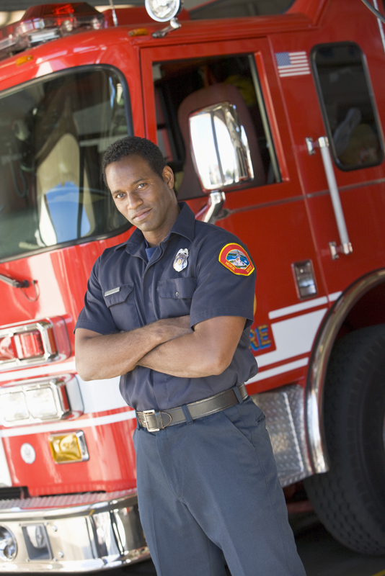

# 1: Sometimes a local hero is obvious, the policeman who risks their life to protect us from violence or the fireman who pulls people out of burning buildings.

# 2: Other heroes that come to mind are the ambulance drivers, paramedics, doctors and nurses who save lives everyday.

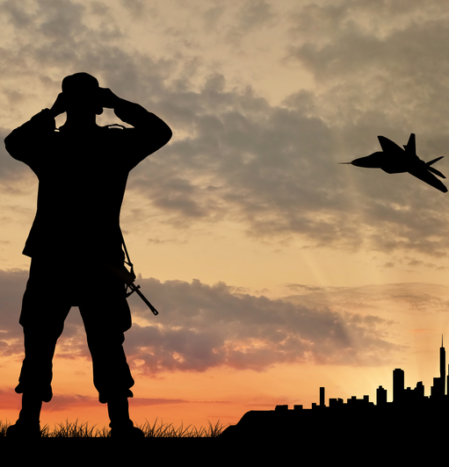

# 3: Some people around us seem like regular people, but they are heroes because they used to be soldiers in the military and served our country to keep us free.

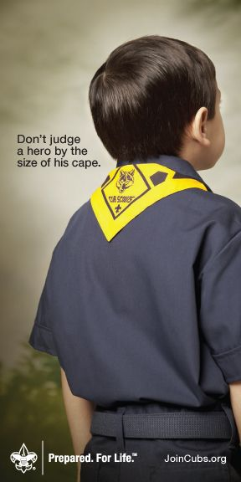

# 4: A hero is someone who does the right thing even when they are afraid of failure. They do it because it should be done.

# 5: Some heroes are harder to spot, but they are still there. My heroes include the people who donate blood, teachers who spend their time and energy helping kids, and kids who say “No” to drugs.

# 6: Heroes are all around us. Please join in saluting all the heroes of our country, by repeating with me the Pledge of Allegiance to the Flag.

Podium Script: Advancement Ceremony

Advancement Ceremony
Cubmaster: As Cub Scouts, we must be aware of being fire safe. As we develop in Scouting, our knowledge increases, our awareness of safety protects ourselves and those who live, play and work with us. Our responsibility to be fire safe and guide others increases as time goes on. Cub Scouts also learn how to take care of themselves and how to give first aid. They learn to stay calm, Be Prepared, and to do their best to be helpful in an emergency. While hoping they never have to, our Cub Scouts know how to come to the rescue.

“Lions are introduced to the Scout Law, which teaches us that a Scout is helpful and can come to the rescue when needed. Lions also demonstrated what to do in an emergency. Would the Lions please come forward with their parents or guardians? (Present awards and lead cheer).

“Tigers learned to come to the rescue by staying calm and asking for help when in an emergency. Tiger learned how to be safe and smart, how to Stop, Drop and Roll, how to plan an escape route from their home, and check the smoke detectors. Would the Tigers please come forward with their parents or guardians? (Present awards and lead cheer).

“Advancing in knowledge are Wolves. Wolves have learned about outdoor fire safety for a campfire, and how to come to the rescue by having a plan and being prepared for emergencies. Would the Wolves please come forward with their parents or guardians? (Present awards and lead cheer).

“Bears learn how to come to the rescue by avoiding accidents with knives and while camping. They learned about cooking and cooking safety, what to do for burns, and how to safely cook a foil pack over a fire. Would the Bears please come forward with their parents or guardians? (Present awards and lead cheer).

“The fourth grade Webelos Scouts have increased their knowledge of fires and fire safety and learned even more outdoor fire safety learn how to come to the rescue of others by being a first responder. Would the fourth grade Webelos Scouts please come forward with their parents or guardians? (Present awards and lead cheer).

“Our fifth grade Webelos Scouts learn to come to the rescue of our world. They have built fires, maintained them safely, and, used them for cooking. They have learned what to do if a fire is in their campsite. And how to light a fire without matches. Would the fifth grade Webelos Scouts please come forward with their parents or guardians? (Present awards and lead cheer).
Podium Script: Cubmaster Minute

Be Prepared

Being a hero does not mean that you must risk your own life. It can mean getting help, or making a phone call to 911 to get the police, or fire department, or ambulance. The key is to use wisdom and judgment, but to do it quickly.
Sometimes time is limited. You can save a drowning person by pulling them in with a life ring, and not become a victim yourself by jumping in after them. Many times, an adult’s life has been saved because a child knew to call 911 in an emergency and get help right away.
You never know when or where emergencies will arise. Cub Scouting teaches us to handle these situations. We don’t expect to get hurt, and don’t expect to need first aid, but we are prepared just in case. Do Your Best!

Closing Ceremony: Print front to back

# 1: H is for Help.
Help is on the way.
A hero is someone who helps.

# 2: E is for Everyone.
Everyone can be a hero.
You just have to be prepared and know that you can make a difference.

# 3: R is for Remember.
Remember that even brave people can be afraid.
It is taking action, even when you are scared that makes you brave.

# 4: O is for One Person

One Person can make a difference.

One person who helps can change someone’s world.

CHEERS

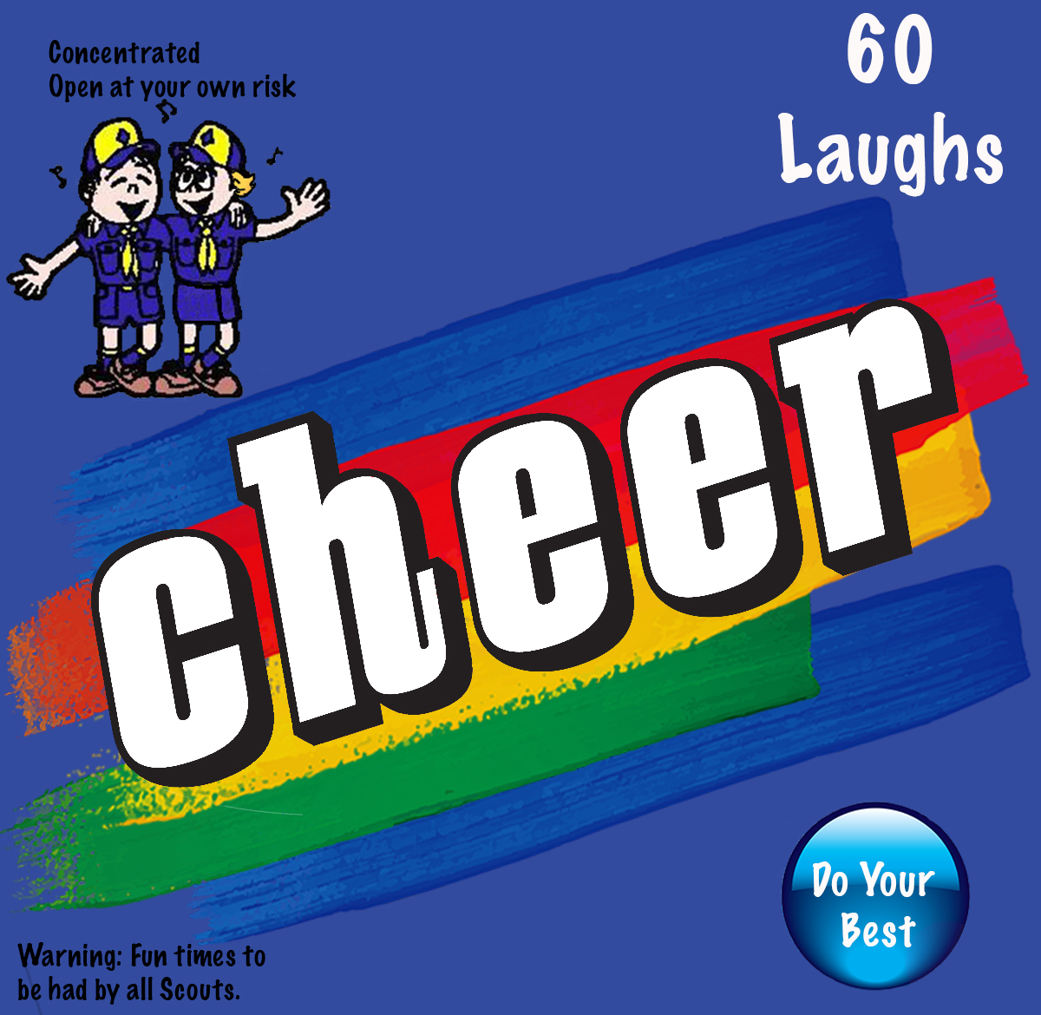
Cheers and applauses are a great way to recognize Scouts and Scouters at den or pack meetings for accomplishments and performances. Cheers add fun to den meetings, pack meetings and campfire programs.

Before starting a cheer or applause, make that everyone knows and understands how to do it. Cheers and applauses serve more than one purpose -- they not only provide recognition but also help liven up a meeting. They need to be fun. Strive for quality of performance. Another important side effect is they provide” wiggle time” for Scouts and siblings during the ceremonies so they sit still during the serious moments. It is a lot easier and a lot less stressful to lead a cheer and have fun than to be constantly reminding the Scouts to sit quietly.

How to Make a Cheer Box. The cheer graphic can be printed and attached to a blue bag or a box wrapped in blue construction paper. Print the cheers on strips of paper and keep generic cheers stuffed in the box. Use theme-based cheers for special meetings. Assign someone (e.g., assistant Cubmaster) to jump up and enthusiastically lead cheers throughout the meeting (e.g., after a skit or advancement ceremony). Let a Scout pull a cheer out of the box and help lead it. Download the cheer box graphic at shac.org/cheers

Print: Cheers and Applause's (cut into strips and put in Cheer box)

Campfire: Look around pretending to gather some wood and tinder. Begin building your fire. Light the fire by striking the match on your backside. As the fire starts say, "Crackle, Crackle, Crackle."

Fire 1: Shout "Call 911! Call Smokey the Bear! Our fire's out of control!"

Fire 2: Make the noise of the fire, "Crackle, crackle, pop" (moving fingers overhead.) Make noise of fire engine, "Whee, whee," act like holding hose, putting out the fire. Have fingers and hands flutter down with "Shhhhhhh, shhhhhhh" noise.

Fire 3: Hold hands out in front of you as if in front of a campfire, sigh and say, "I feel warm all over!"

Fire 4: Gather wood, lay down in front of you, take match from pocket, strike match, light wood. Say "ooh A ooh!"

Fire Bucket Brigade Cheer: Pretend to pass buckets of water, throw water on fire saying “SWWWOOOSSSHH.”

Fire Engine Cheer:
Divide into four groups.
  - 1. Bell… “ding, ding, ding.”
  - 2. Horn… “honk, honk, honk.”
  - 3. Siren… “rrr, rrr, rrr.”
  - 4. Clanger… “clang, clang, clang.” Have everyone yell at once.

Firefighter Applause:
    - Make sounds, “Crackle, crackle, pop” as you move your fingers over your head.
    - Then make a sound like a fire engine.
    - Grab your hose and spray on the fire and “hiss-s-s”
    - Say “The fire is out.”

Firefighter Cheer: “WATER! WATER! WATER!”

Find more generic cheers at shac.org/cheers.
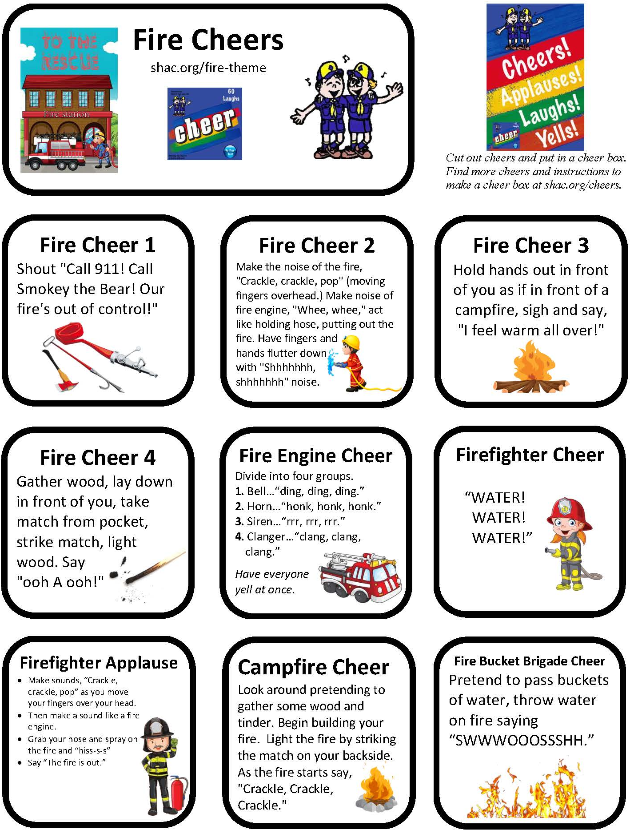

MEETING HANDOUT

Edit the text boxes on the next two pages. An editable, word version of this document is available at www.shac.org/fire-theme.
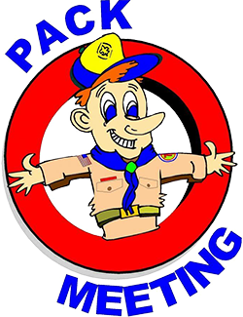
- Page 1: insert pack number and month/year
- Page 2: list detailed announcements, edit upcoming events for next three to six months, customize electronic communications.

Print one copy per person (of next two pages), one-sided to two-sided

Announcements: During meetings, keep announcement very short. Having detailed announcements printed in the handout saves times during meetings and avoids the dreaded long announcements that run on and on (that nobody can hear, nobody pays attention too and Scouts dislike). Encourage the parents to put the handout on their refrigerator. Parents will get used to getting a handout at each pack meeting.

Songs: have more songs than you think you need. You don’t have to sing them all, but having a back-up in case of a lull in the program is always helpful.

 | Pack <#> |  |  | 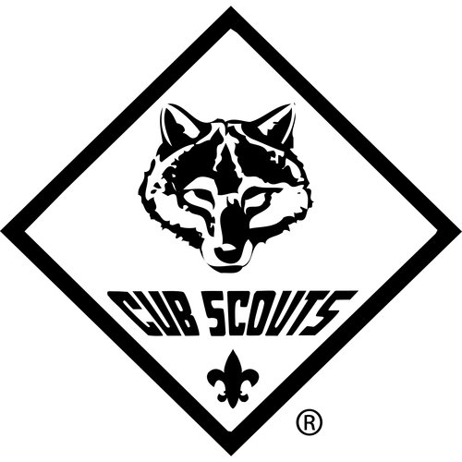 | <month year>
I Wish I Were a Volunteer Firefighter  Tune: Oscar Meyer Weiner  Oh, I wish I were a volunteer firefighter,  That is what I’d really like to be.  ‘Cuz if I were a volunteer firefighter,  Everyone would look up to me.  I’d climb a ladder up high to save babies.  I’d battle fire, smoke and burning steam.  I’d wear my big, red fireman’s cap proudly,  And polish my badge until it gleamed.  I’d rescue cats from limbs in very tall trees  And do inspections very carefully,  I’d teach the kids to all be fire detectives  ‘Cuz then my job would be so easy. |  |  | 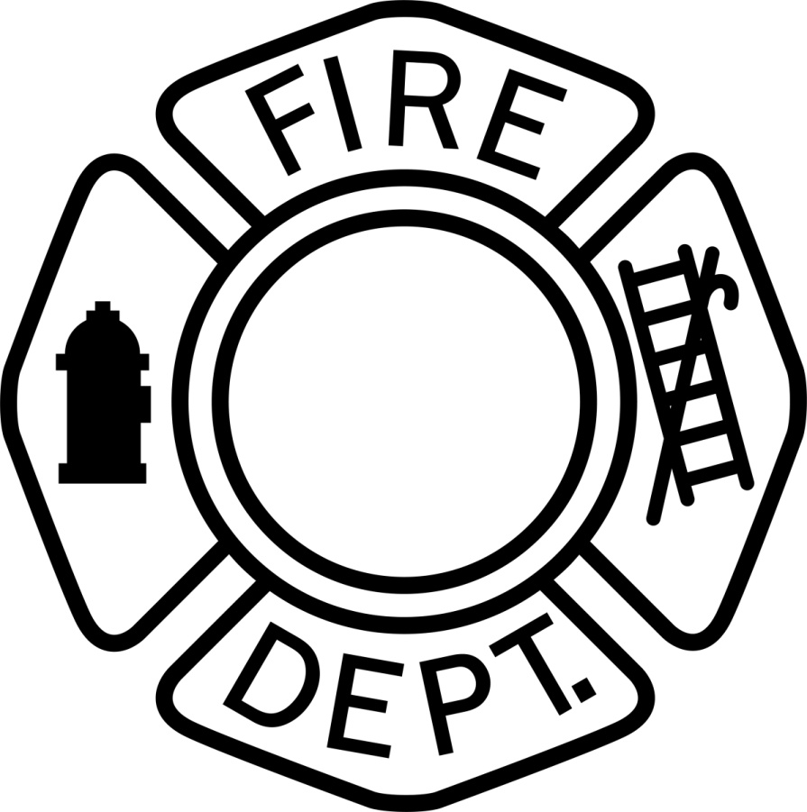 |  |  |  | 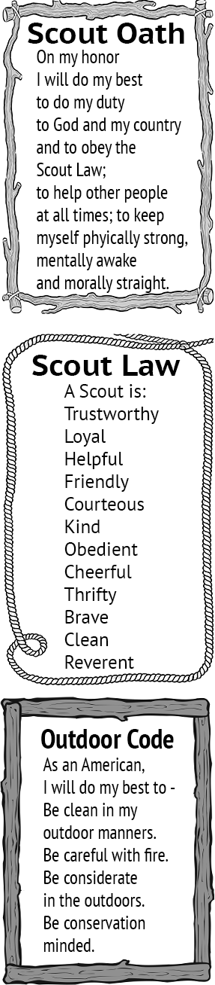
Thinking Safety
Tune: Clementine
In the kitchen, dad was cooking,  Frying chicken in some oil.  Said he’d go out to do the shopping,  Just as dinner tried to boil!  Thinking safety, I remembered,  Told him, “Dad! Turn off the heat!”  Using caution is more important  Than preparing supper meat.  At the table was a candle  Mom had lit to cheer the room.  Matches sitting on the counter  Made me feel a sense of doom.  Thinking safety, I remembered,  Told her, “Mom, this I must teach,  Keep the matches and the lighters  Out of little sister’s reach!” |  | In the bedroom, brother studied,  Working oh so diligently,  Stereo, TV, heater, computer,  All plugged in the same circuitry.  Thinking safety, I remembered,  Told him, “Bud, that’s not too wise!  You should unplug some electronics  Before that one connection fries!”  Fire prevention can be easy,  Just have care at every turn.  Use your good sense and some planning  To prevent unwanted burn.  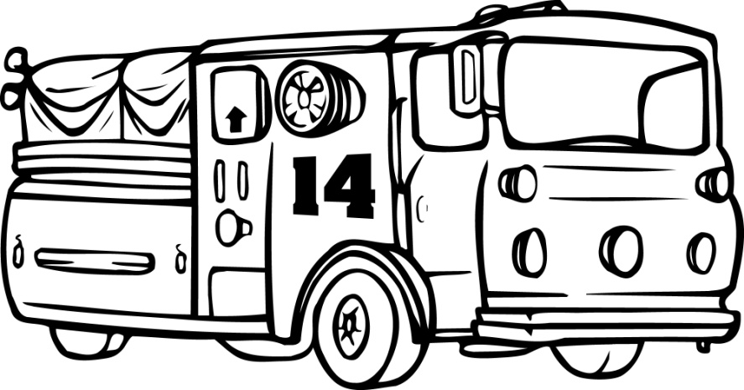

< insert details about upcoming pack, district and council events.  Find district event information on your district website.  Find upcoming council event articles in the Scouting Trail at www.shac.org/toolkit.> |  |  |  | Upcoming Events  <Month Year>  <day> <event>  <day> <Den meeting>  <day> <Pack meeting>  <day> <District event>  <day> <Council event>  <Month Year>  <day> <event>  <day> <Den meeting>  <day> <Pack meeting>  <day> <District event>  <day> <Council event>  <Month Year>  <day> <event>  <day> <Den meeting>  <day> <Pack meeting>  <day> <District event>  <day> <Council event>  <Month Year>  <day> <event>  <day> <Den meeting>  <day> <Pack meeting>  <day> <District event>  <day> <Council event>  <Month Year>  <day> <event>  <day> <Den meeting>  <day> <Pack meeting>  <day> <District event>  <day> <Council event>
<insert pack committee and contact info>  Name Committee Chair Email  Name Cubmaster Email  Name Secretary Email  Name Treasurer Email  Name Popcorn Chair Email  Name Scout Fair Chair Email  Name Banquet Chair Email |  | 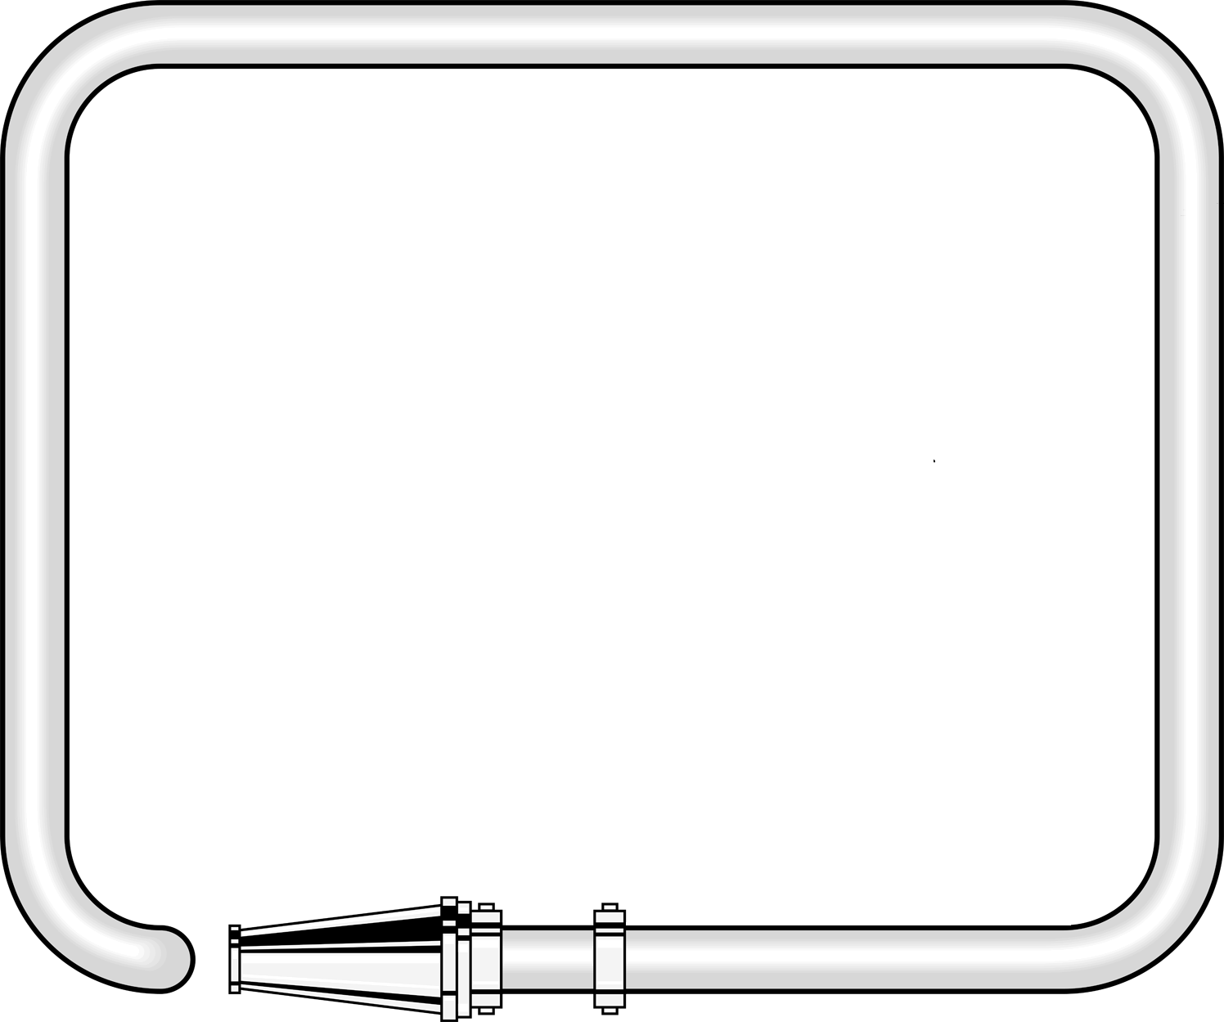  Pack <#>  facebook.com/<insert URL>  <pack website>  <insert> District  <district website>  facebook.com/<insert URL>  Sam Houston Area Council  www.shac.org  facebook.com/shac.bsa

BANQUET HANDOUT

For banquets a more formal handout can be used.
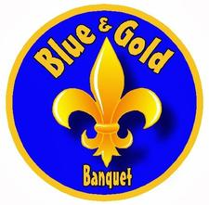
Edit the text boxes in the next two pages (insert Scout’s names, upcoming events, pack number, agenda and date). An editable, word version of this document is available at www.shac.org/fire-theme.

Print one copy per person (of next 2 pages), front to back.

Banquets: Most packs celebrate Scouting Anniversary Week in February with a birthday party called the blue and gold banquet; some packs do end of the year banquets. It brings families together for fun and cheer. The purpose of a banquet is to celebrate the Scouting, thank leaders and volunteers, and inspire the leaders, Scouts, and parents.

The banquet can be like a regular pack meeting with songs, skits, stunts, and awards, or it can be something different and a little more special. The pack committee may decide to bring in an entertainer such as a mad scientist or magician and have a video or slide show of what the pack did over the past year.

A good banquet needs lots of careful planning at least two months in advance to be successful. The pack committee should recruit a banquet chair, who in turn may select others to carry out the responsibilities of the program, such as making physical arrangements, promotions, inviting special guests, decorations, choosing a theme, ordering food, etc.

A detailed plan for banquets, including a planning calendar, sample agenda, and suggested program activities, is available in the Cub Scout Leader How-To Book, No. 621165.

Banquet Planning: www.skcscouts.org/wp-content/uploads/2013/06/Blue-Gold-Planning-Guide.pdf

Banquet Planning: www.ocbsa.org/wp-content/uploads/2011/06/Blue-Golf-Banquet-for-Website.pdf

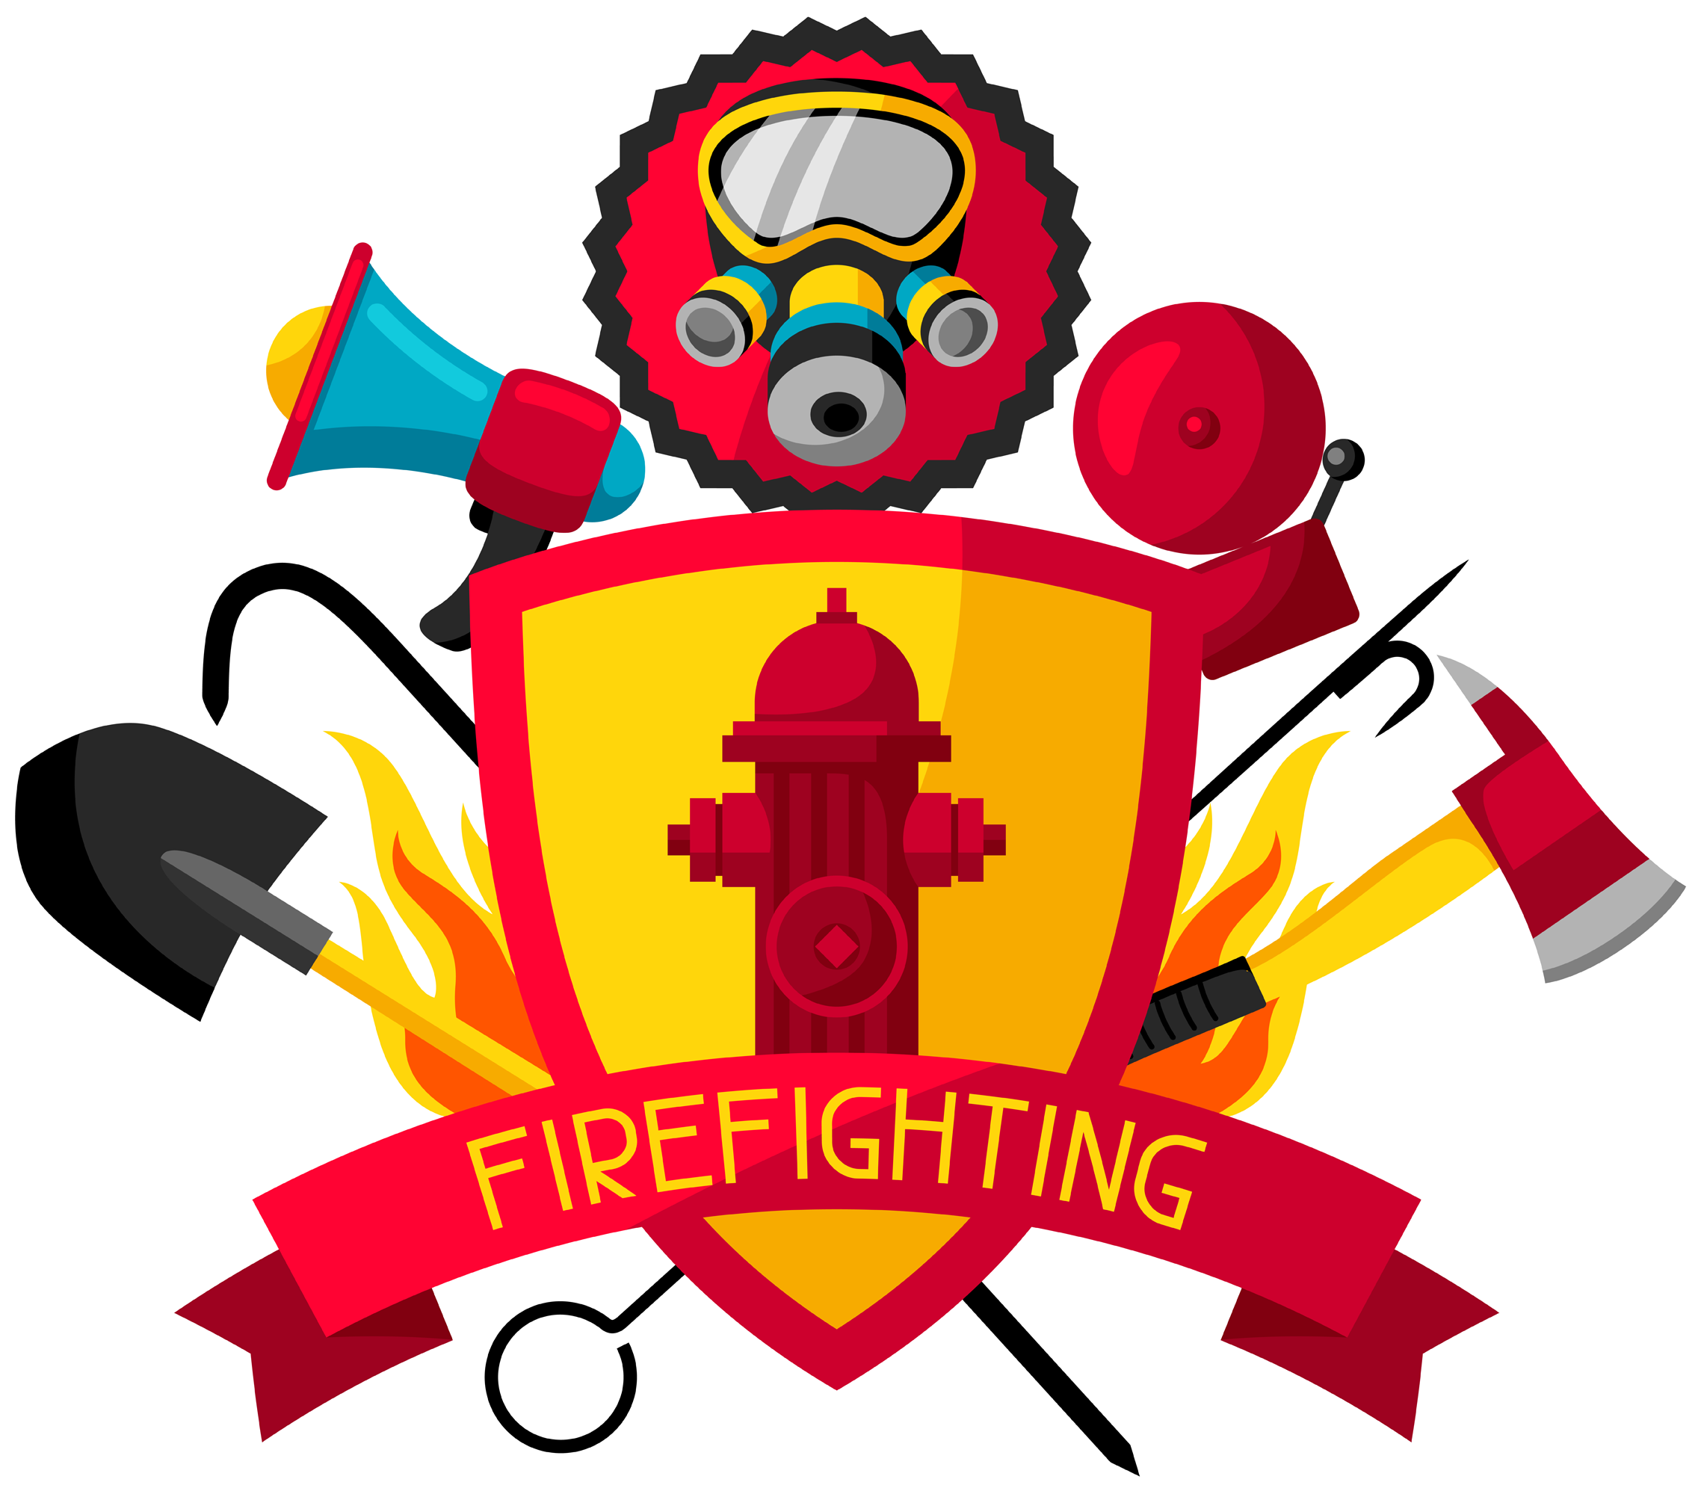
Blue and Gold
Banquet
Lions  Sally Lion  Bobby Lion  Tigers  Molly Tiger  Brian Tiger  Wolves  Susy Wolf  Cameron Wolf |  | Bears  Carsten Bear  Jane Bear  Webelos Scouts  Bill Webelos  Joy Webelos  Laura Webelos  Scott Webelos

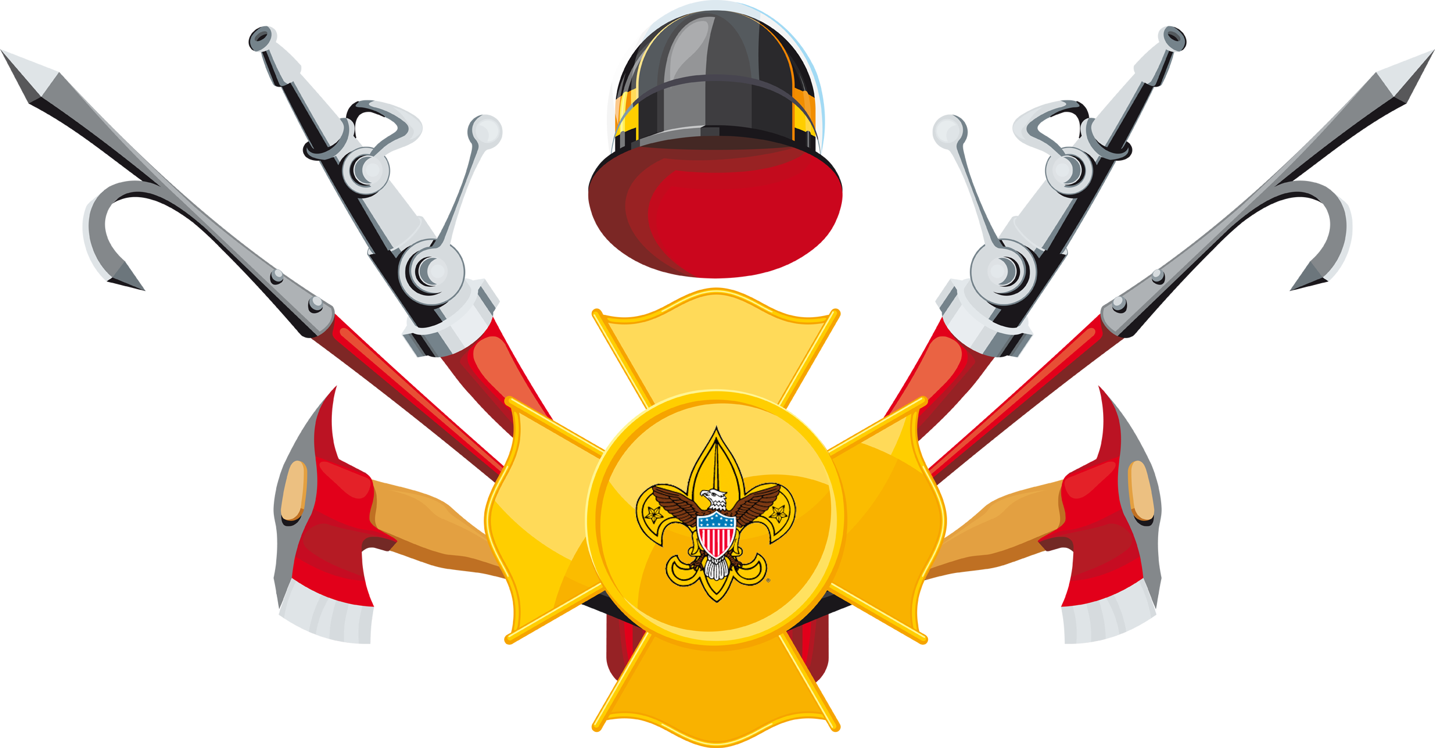
Upcoming Events
May 19, 2020
Pack 72
<date> <event>
<date> <event>
<date> <event>
<date> <event>
<date> <event>
<date> <event>

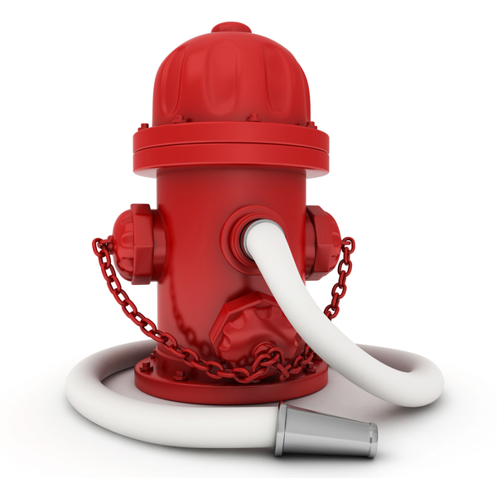
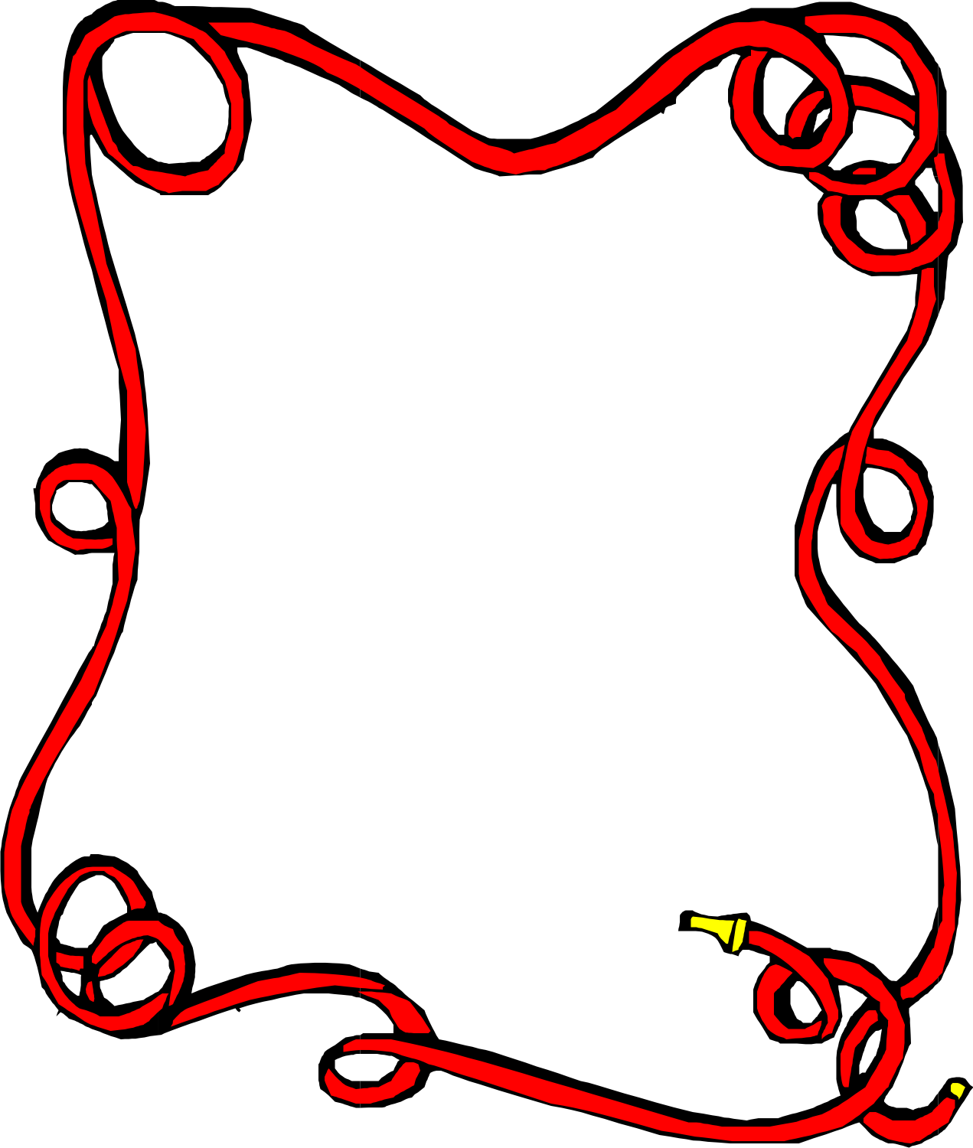
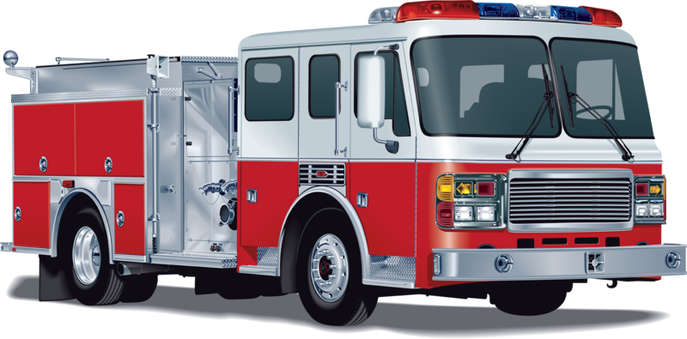
Gathering

Opening

Invocation

Dinner

Friends of Scouting Presentation

Advancement Ceremony

Song

Leader Recognition

Cubmaster Minute

Closing
www.facebook.com/pack72tomball
www.facebook.com/orionbsa
www.facebook.com/shac.bsa
www.orion.shac.org
www.shac.org
I Wish I Were a Volunteer Firefighter
Tune: Oscar Meyer Weiner

Oh, I wish I were a volunteer firefighter,
That is what I’d really like to be.
‘Cuz if I were a volunteer firefighter,
Everyone would look up to me.

I’d climb a ladder up high to save babies.
I’d battle fire, smoke and burning steam.
I’d wear my big, red fireman’s cap proudly,
And polish my badge until it gleamed.

I’d rescue cats from limbs in very tall trees
And do inspections very carefully,
I’d teach the kids to all be fire detectives,
‘Cuz then my job would be so easy.

Thinking safety, I remembered,
Told her, “Mom, this I must teach,
Keep the matches and the lighters
Out of little sister’s reach!”

In the bedroom, brother studied,
Working oh so diligently,
Stereo, TV, heater, computer,
All plugged in the same circuitry.

Thinking safety, I remembered,
Told him, “Bud, that’s not too wise!
You should unplug some electronics
Before that one connection fries!”

Fire prevention can be easy,
Just have care at every turn.
Use your good sense and some planning
To prevent unwanted burn.

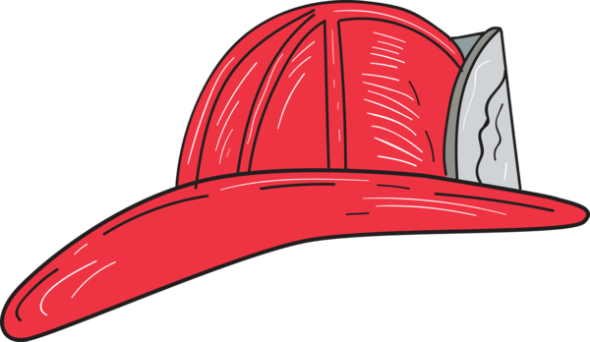
Thinking Safety
Tune: Clementine

In the kitchen, dad was cooking,
Frying chicken in some oil.
Said he’d go out to do the shopping,
Just as dinner tried to boil!

Thinking safety, I remembered,
Told him, “Dad! Turn off the heat!”
Using caution is more important
Than preparing supper meat.

At the table was a candle
Mom had lit to cheer the room.
Matches sitting on the counter
Made me feel a sense of doom.

ADVANCEMENT CEREMONIES

Advancement Ceremony
For each rank, call each Cub Scout and their parents or guardians by name and ask them to step forward.
Cubmaster: In Cub Scouting, the Cub Scouts learn how to take care of themselves and how to give first aid. They learn to stay calm, Be Prepared, and to do their best to be helpful in an emergency. While hoping they never have to, our Cub Scouts know how to come to the rescue.
“Lions are introduced to the Scout Law, which teaches us that a Scout is helpful and can come to the rescue when needed. Would the Lions please come forward with their parents or guardians? (Present awards and lead cheer).
“Tigers learn to come to the rescue by staying calm and asking for help when in an emergency. Would the Tigers please come forward with their parents or guardians? (Present awards and lead cheer).
“Wolf Scouts learn to come to the rescue by having a plan and being prepared for emergencies. Would the Wolves please come forward with their parents or guardians? (Present awards and lead cheer).
“Bears learn how to come to the rescue by avoiding accidents with knives and while camping. Would the Bears please come forward with their parents or guardians? (Present awards and lead cheer).
“Webelos Scouts learn how to come to the rescue of others by being a first responder. Would the fourth grade Webelos Scouts please come forward with their parents or guardians? (Present awards and lead cheer).
“Our fifth grade Webelos Scouts learn to come to the rescue of our world. Would the fifth grade Webelos Scouts please come forward with their parents or guardians? (Present awards and lead cheer).
Do Your Best in an Emergency
Cubmaster: In Cub Scouting, the Cub Scouts learn how to take care of themselves and how to issue first aid. They also learn what to do in case of a vehicle accident, family illness, or how to stop, drop and roll if they are on fire.
Asst CM: This month we have been learning about the people who help us in an emergency. Like the Cub Scouts, they do their best. The Cub Scout motto is: "Do Your Best." This is one of the things the Cub Scouts are always trying to do. We cannot ask more of someone.
Cubmaster: Would (call up a rank) please come forward with their parents or guardians? These Cub Scouts have worked hard to do their best in earning the rank of .
We present this badge to their parents to pin on him (Present the award and lead cheer).

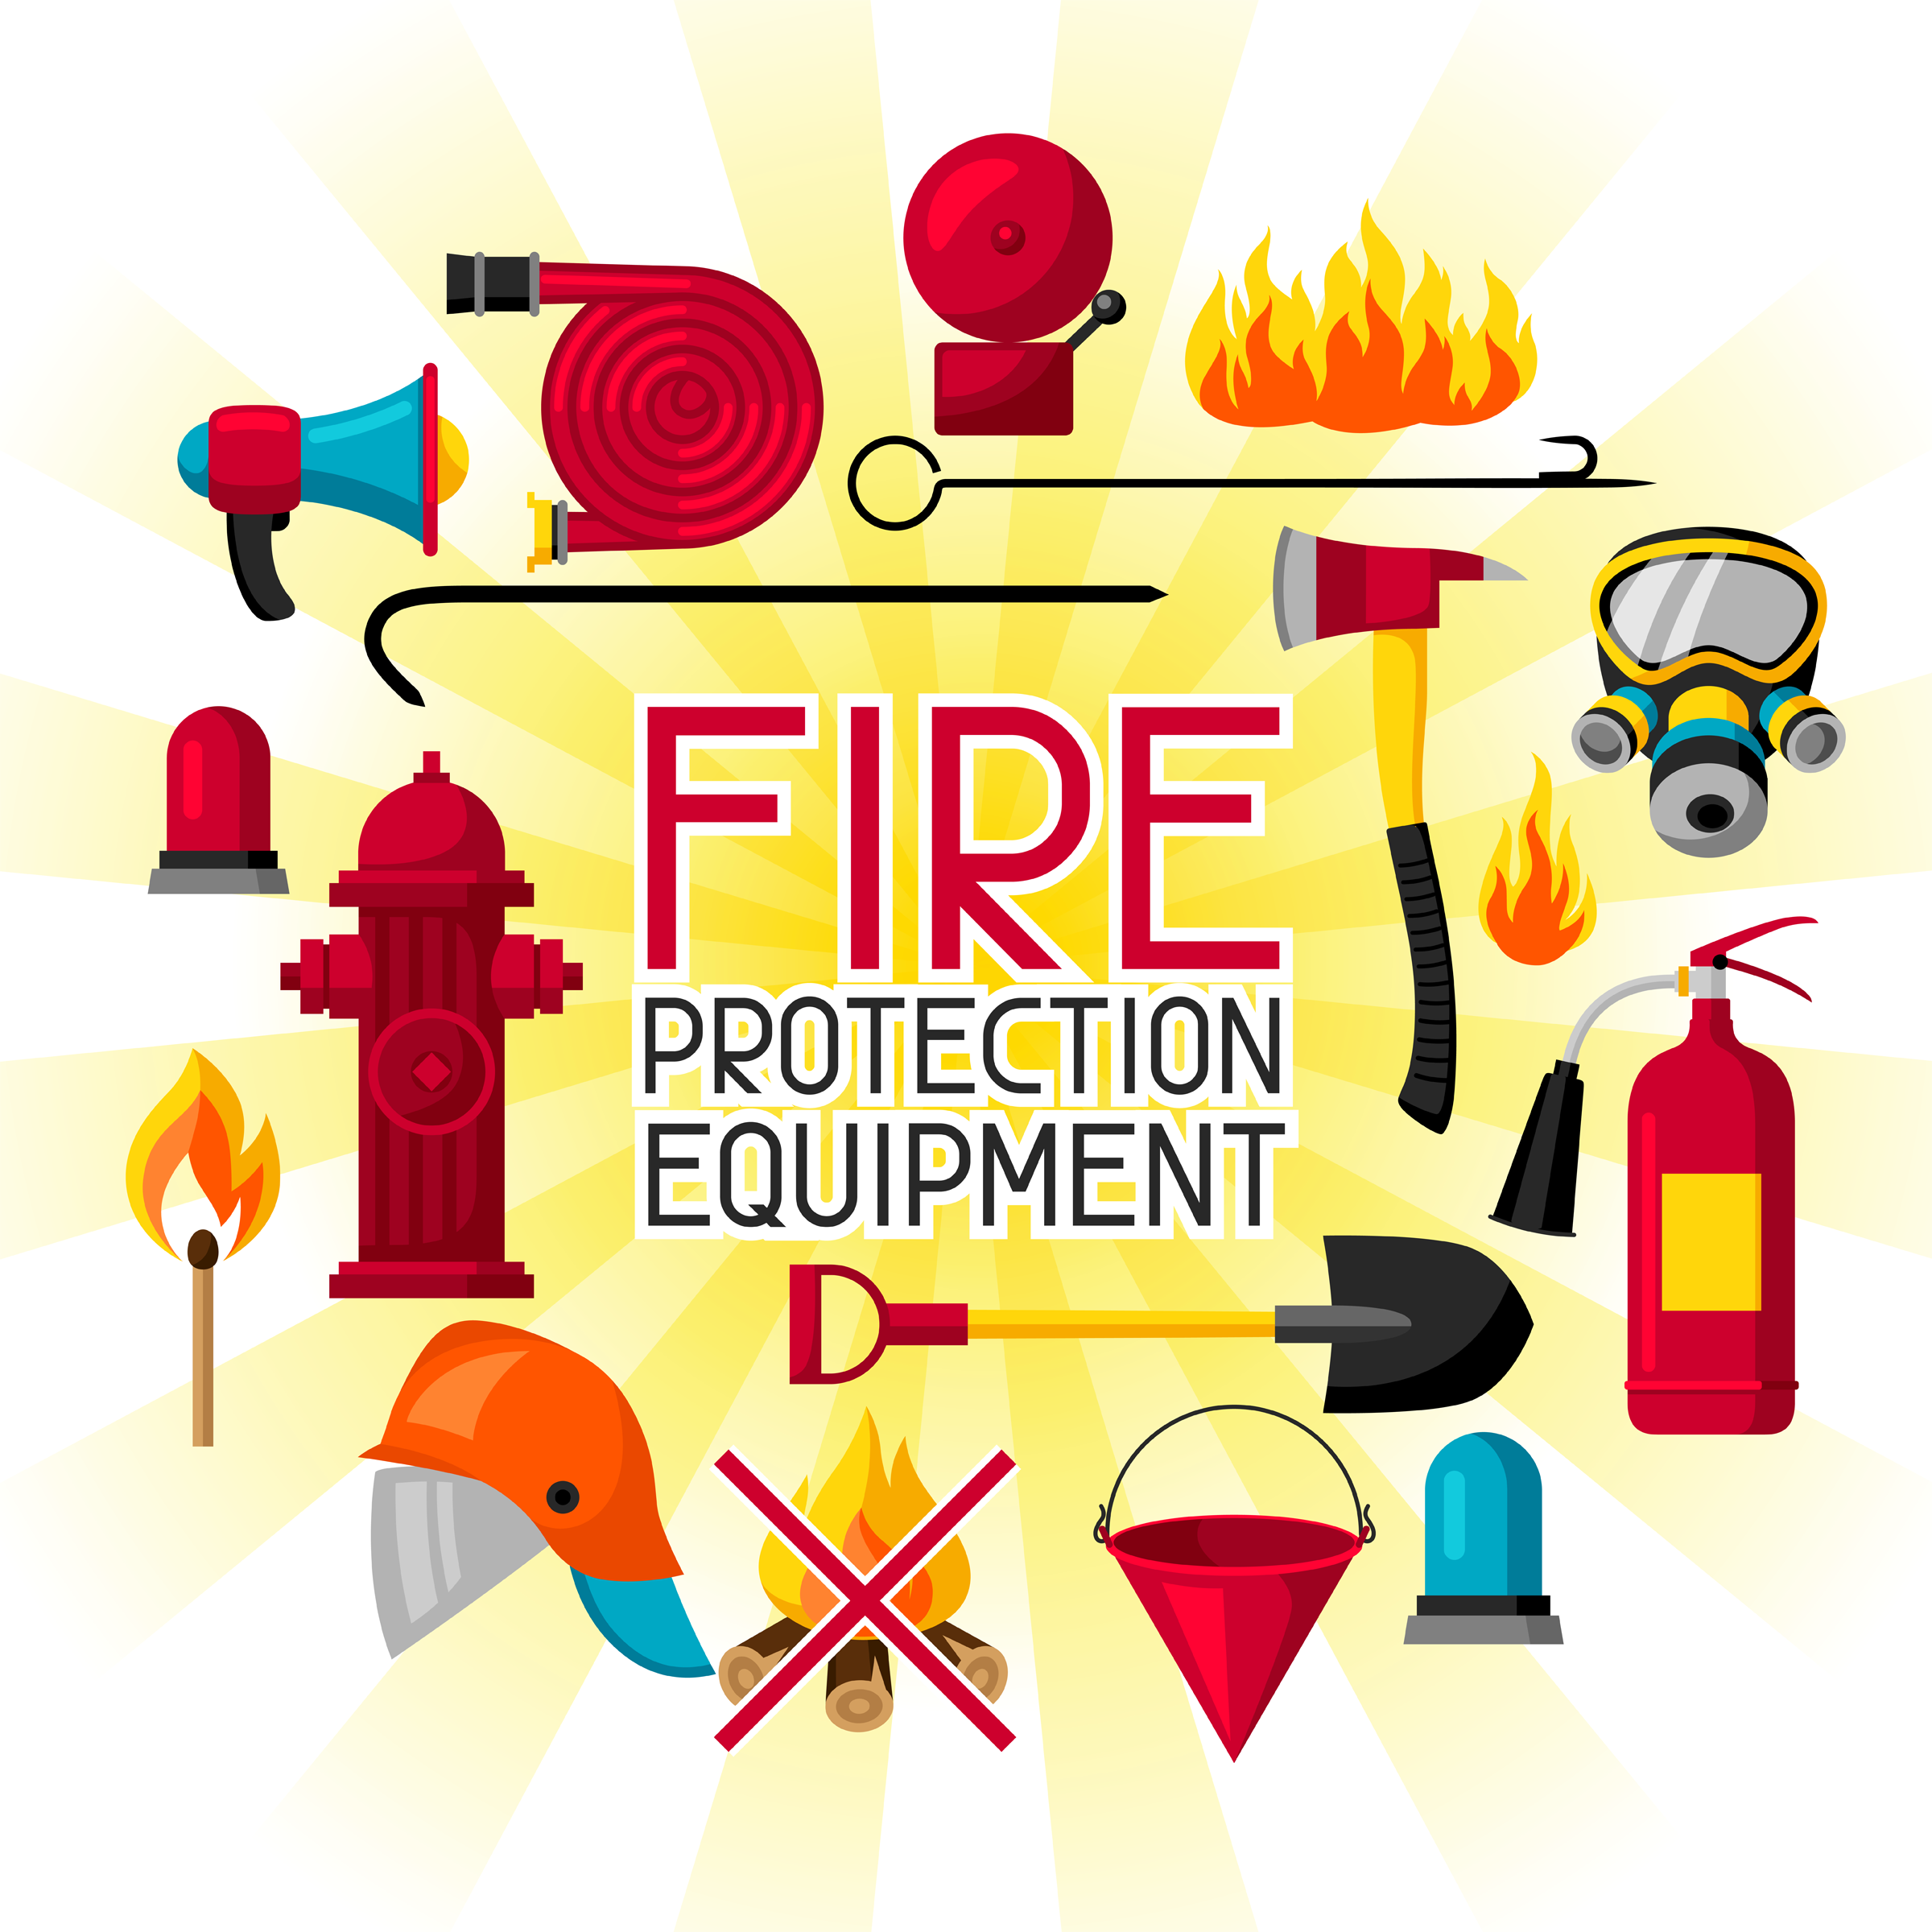

Fire Safety Advancement Ceremony

As Cub Scouts we must be aware of being fire safe. As we develop in Scouting, our knowledge increases, our awareness of safety protects ourselves and those who live, play and work with us. Our responsibility to be fire safe and guide others increases as time goes on.

Entering into this beginning class are our new Lions. Will these Lions and their parents come forward? These Lions are beginning their experiences in Cub Scouting. (Present the awards and lead cheer).

Advancing forward are Tigers. Tiger learn how to be Safe and Smart. They learn how to Stop, Drop and Roll, plan an escape route from their home, and check the smoke detectors. (Present the awards and lead cheer).

Advancing in knowledge are Wolves. In the Call of the Wild Adventure, Wolves learn about outdoor fire safety for a campfire. (Present the awards and lead cheer).

Another achievement in Cub Scouting Bears. They learn about cooking and cooking safety, what to do for burns, and how to safely cook a foil pack over a fire. (Present the awards and lead cheer).

The Webelos Scouts increase their knowledge of fires and fire safety and learn even more outdoor fire safety while working on the Webelos Cast Iron Chef, Camper, and Castaway Adventures. They build fires, maintain them safely, and, use them for cooking. They learn what to do if a fire is in their campsite. And how to light a fire without matches.
(Present the awards and lead cheer).

To Help Other People at All Times
Props: A small taper candle for each Scout, A candelabra with three candles either all white or one red, one blue, and one white.
Note – add in the actual award names to personalize this ceremony. Have more Scouts, use a Scout to light the other candle.
Cubmaster: “To help other people at all times,” is the second of the three duties of a Scout expressed in the Scout Oath. Helping other people is part of what it means to be a good neighbor. We have to help and look out for each other. I will light the second candle to represent our duty to others. Tonight, would like to recognize several Scouts who with the help of their mothers, fathers, den leaders, and others have met the requirements for advancement to the next rank.
Assistant CM: Will Cub Scouts and please come forward with their parents? Will one of the parents please light the first candle, which represents a Scout's Duty to God and their Country? Duty to God and Country is the first duty of a Scout expressed in the Scout Oath.
CM: Will Cub Scouts and please come forward with their parents? Will one of the parents please light the third candle, which represents a Scout's Duty to himself? This duty is expressed in the words, "Keep myself physically strong, mentally awake, and morally straight." This is the third duty of a Scout expressed in the Scout Oath.
Cubmaster: I will now present these awards which represent your Scouts' accomplishments to you, the parents, to present to your sons. I do this because you have helped them the most to earn the award and deserve the honor of presentation more than I do.
Now, you may present the award to your son.
Assistant CM: lead cheer.

AUDIENCE PARTICIPATIONS

Clancy To the Rescue
Divide audience up into six groups. Assign each group a response to do whenever their word is spoken in the story. Practice as you assign parts. If your group is small, have everyone react to the last two items. If group is larger, divide into seven groups and assign STEAM. ASLEEP only occurs once at the very end.

CLANCY: Feel your muscles, like a strong man
HORSES: Slap Thighs
YELL: Use your hand over your mouth
FIRE ENGINE: High-pitched siren sound
BELL: Swing arm like a clapper saying, “Clang, clang, clang!”
HOSE: Shh-sh-sh sound like water from a hose
STEAM: Everyone makes high pitched Sssss sound
ASLEEP: Everyone snores

If you like HORSES, you would have enjoyed living back in the 1800's when they had old-fashioned STEAM type FIRE ENGINES pulled by HORSES. One of the FIRE ENGINES was driven by the greatest hero ever, CLANCY! Yes, Sir! CLANCY was a real hero. Every day when there was no fire, he would take the HORSES out for exercise, trotting them gently up and down the streets. If there were children along the way, CLANCY would always stop and let them pet the HORSES.
Sometimes the alarms were in the daytime, but sometimes they were at night. When the alarm sounded at night, one man would YELL up to the firemen above, and the men would run to the FIRE ENGINE where the STEAM was started up, and away they would go to the fire, clanging the BELL, with CLANCY driving the HORSES.
One night most of the men were in bed and the others were playing checkers when the alarm sounded. Where was the fire? At the mayor's big two-story house! The YELL was given and quick as a flash the firemen were up and on their way. CLANCY stopped the HORSES and YELLED,
“Keep the STEAM up men." They started the fire HOSE and began to squirt water on the fire. CLANCY strained to see upstairs where the mayor's wife was trapped. Flames were everywhere! CLANCY YELLED, "You'll have to jump!" The mayor's wife was afraid, so CLANCY threw her a rope and she came right down into the middle of the net.
The firemen kept fighting the fire. They got the HOSE on it and kept up the STEAM in the FIRE ENGINE. Before long, the fire was out, so they turned off the HOSE, got back on the FIRE ENGINE and went back to the fire house, clanging the BELL. To CLANCY and the other firemen, it was all in a day's work. The tired firemen went back upstairs and soon were sound ASLEEP.

The Spark Watcher
Divide audience into 6 groups. Assign each group a response to said when their word is read in the story. Practice as you assign the parts. Encourage VOLUME
Little Fire Engine: “Ding ding” Big Fire Engine: “Clang clang” Pumper: “Pump pump”
Fire Chief: (Siren sound) Fire: “Crackle crackle” Toys: “Ha-ha, ho-ho”
Once there was a LITTLE RED FIRE ENGINE who lived in a toyshop. “I’d like to go to a real FIRE just once,” said the LITTLE RED FIRE ENGINE to the other TOYS. “ I could watch the FIRE CHIEF, the BIG FIRE ENGINES and the PUMPERS shoot streams of water all over, and maybe then they would let me help put out the FIRE.”
“Pooh,” said the TOYS. “You’re only a LITTLE TOY FIRE ENGINE, you wouldn’t be any help at a big FIRE.” All the TOYS laughed at him. “You’ve never even seen a FIRE,” said the TOYS. “How would you know what to do? You’d only be in the way.”
The LITTLE FIRE ENGINE rumbled off to a corner by himself. He thought that he might be in the way, but he might be good at fighting FIRES. “I’ll never know until I try. I’ll have to go to a FIRE and see.” So, the LITTLE FIRE ENGINE decided to go to a FIRE.
That very afternoon, he heard the siren blow. Out the open toyshop door he dashed, and stood at the curb panting. The BIG RED FIRE ENGINE, the PUMPER, and the FIRE
CHIEF went tearing by. “Wow!” said the LITTLE FIRE ENGINE, “I didn’t know real fire engines were so very, very big!” But, he hurried down the street anyway. He did his best to keep up, but the BIG FIRE ENGINE got to the FIRE first. When the LITTLE FIRE ENGINE got there, the BIG FIRE ENGINES were already at work. The long hoses were twisting and winding all around. The LITTLE FIRE ENGINE could hardly get through. He puffed and panted over one hose and then another. At last, he was close to the FIRE, and he looked around for a job to do.
“I’ll shoot water,” thought the LITTLE FIRE ENGINE, but his hose was too short. In spite of all he did, the FIRE burned brighter. “I wish someone would tell me what to do,” the LITTLE FIRE ENGINE said.
The PUMPER was busy shooting water and the BIG FIRE ENGINE was running up ladders for the fire fighters, while the FIRE CHIEF ran around giving orders. They had plenty to do, and they didn’t even notice the LITTLE FIRE
ENGINE was there. They pushed him to one side, out of the way. He had to be very careful that he wasn’t run over.
“I guess I don’t belong here,” the LITTLE FIRE ENGINE thought sadly. “I’m too little for such a big FIRE. I better go back with the rest of the TOYS.” But, just as he started to leave, he saw a spark fly from the burning building. It landed right beside him, and started to burn.
“Here,” said the LITTLE FIRE ENGINE, “This will never do.” He turned his hose on the little FIRE; his hose was just the right size. In an instant, the FIRE was out. He had an idea. He’d be a spark watcher. So he raced around looking for flying sparks. Whenever the LITTLE FIRE ENGINE saw one, he hurried to put it out.
He got all hot and smoky, just like the BIG FIRE ENGINE. He was so successful that the FIRE CHIEF’S car, the PUMPER and the BIG FIRE ENGINE called to him, “Why don’t you stay with us in the fire house, LITTLE FIRE ENGINE? We could use you.” He was delighted. And so, the LITTLE FIRE ENGINE lived from then on with the BIG FIRE ENGINES and became the best spark watcher in town!

CLOSING CEREMONIES

Closing Ceremony
(Light candle before starting ceremony)
A group of Cub Scouts rush into the room, imitating a fire brigade, circles the room and rush toward the fire.
One or two Cub Scouts might be sirens, another ring bells, several could carry a hose, one a bucket.
They all rush toward the candle and just before they get there, the Cubmaster blows the candle out.
The Cub Scouts look disgusted and walk away.
The Cubmaster says, “Good night everyone!”

Battery Check
Personnel: 6 Cub Scouts
Equipment: Smoke Detector and new Batteries
# 1: Brings out the smoke detector and places on a table
# 2: Checks for a sound, pushing button - nothing happens.
# 3: Comes out and takes out the old batteries.
# 4: Brings out the new batteries and put them in.
# 5: Checks for a sound, pushing button - the smoke detector works.
# 6: “A message to our parents. Please remember to check the batteries in our home smoke detectors tonight. Goodnight.”

HERO Closing
You will need large cards spelling out H-E-R-O, with lines on the back in LARGE print for Cub Scouts to read
# 1: H is for Help. Help is on the way. A hero is someone who helps.
# 2: E is for Everyone. Everyone can be a hero. You just have to be prepared and know that you can make a difference.
# 3: R is for Remember. Remember that even brave people can be afraid. It is taking action even when you are scared that makes you brave.
# 4: O is for One Person One Person can make a difference. One person who helps can change someone’s world.

Smoky Closing
Each Cub Scout should hold up cards to spell “SMOKEY” Words on back in LARGE print
# 1: Smokey the Bear has a message to tell.
# 2: Make it a point to hear him well.
# 3: Only you can prevent forest fires, Smokey says.
# 4: Keep yourself safe in being careful that way.
# 5: Everybody must do their part.
# 6: Yes, we can stop fires before they start

Top Ten Crime Prevention Tips
# 1: Do NOT commit crimes or hang around with people who commit crimes.
# 2: Do NOT use illegal drugs or hang out with people who do.
# 3: Trust your gut instinct. If you get a weird “vibe,” you are probably right.
# 4: Be aware of your surroundings.
# 5: Be rude if you have to. It’s better to be rude than to be a victim.
# 6: Do not leave valuables in plain view.
# 7: Vary your daily routine.
# 8: Know your neighbors and keep you neighborhood clean.
# 9: Use common sense (lock your doors, don’t leave keys in the car, etc.).
All Think!
Have Cubmaster follow up with a Cubmaster’s Minute about being safe and then dismiss the pack.
When Accidents Happen...
A leader may do Cub Scout #5’s part.
# 5: When accidents happen, we are told to call 911 using the telephone. But what if there is no phone available? What if we are out in the woods or on a boat? There are other ways that we can communicate that we need help. Let's have some of our Cub Scouts show us what we could do in such an emergency.
# 1: (carrying a flag upside down) One distress signal is to fly the flag upside down and others will know that you need help.
# 2: (carrying a poster of 3 bonfires burning in a row) Build three fires equally spaced apart.
Remember that a fire will be seen a long way during the night, but smoke is better for day.
# 3: (carrying a horn or whistle) Remember the number three! Three blasts from a horn or a whistle at equal intervals should bring help. (Blow whistle three times)
# 4: (carrying a flashlight or two sticks) Don't forget SOS. You can use a flashlight to signal 3 short, 3 long and 3 short; or you can beat out this Morse code with sticks or on a pipe. (Make signal)
# 5: Knowing how to communicate can save lives, those we love and even our own.

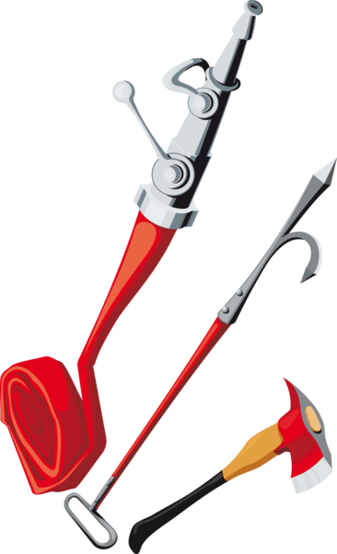

CUBMASTER MINUTES

Be Prepared
Being a hero does not mean that you must risk your own life. It can mean getting help, or making a phone call to 911 to get the police, or fire department, or ambulance. The key is to use wisdom and judgment, but to do it quickly.
Sometimes time is limited. You can save a drowning person by pulling them in with a life ring, and not become a victim yourself by jumping in after them. Many times an adult’s life has been saved because a child knew to call 911 in an emergency and get help right away.

You never know when or where emergencies will arise. Cub Scouting teaches us to handle these situations. We don’t expect to get hurt, and don’t expect to need first aid, but we are prepared just in case. Do Your Best!

Fire Safety Closing
Extinguish the room lights, shine a small spotlight of flashlight on the U.S. flag and ask all to join in singing “God Bless America.” Cubmaster then says, “Cub Scouts, all during our meeting the candle representing the Spirit of Cub Scouting has continued to burn. Now we’ll blow it out, reminding ourselves that a flame must never be left burning when no one is around, but let us keep the light of Cub Scouting burning in our hearts.”

GAMES

Dial 911
Pieces of paper are handed out to the captain of each team. Each paper contains emergency situations, i.e. house on fire, car wreck, cat up a tree. Each captain puts back the paper then goes back to their team and whispers what was written on the paper. Each team member must receive the message to the end. The last person raises their hand then when all the teams are done let each team’s final member repeat the message and compare it to the original. Parents can judge to see which team came the closest.

First Aid Baseball
For this game you will need a small corkboard, permanent markers, push pins, and rank appropriate handbook.
Purpose: Everyone enjoys baseball, so why not test your Scouts knowledge of first aid in a fun manner!
Draw a baseball diamond on the corkboard (or a white (dri- erase) board with appropriate markers.
Divide your Scouts into two teams. Ask each team a question related to the first aid using their handbook as a reference.
Have each team designate one person as the spokesperson for the team. They will be the only person to give the team’s answer. All members of the team are to discuss answers and vote on the correct answer, but only the spokesman gives the answer.
For each correct (simple) answer, you are awarded 1 base. If you ask a multiple part question, the team can be awarded multiple bases if they answer the entire question, award them 2 bases. You keep score just as at a baseball game.
You can designate a time to quit or assign a number of innings to finish the game.
The team with the most runs wins the game. This is a great game to play in the event of rain at an outdoor event.

Fire, Police, Ambulance Game
Three corners of the room are named “Fire Station”, “Police Station”, and “Ambulance”.
The leader calls out a situation in which a Cub Scout might find himself and the Cub Scouts have to run to the correct “corner”
The last one home loses a point for their team. Suggested situations-
1. Smoke is seen coming from under the door of a house. (Fire Station.)
2. Your window cleaner falls from a ladder while cleaning the upstairs bedroom window (Ambulance.)
3. When out fishing you spot some bushes on fire. (Fire Station.)
4. You see some older Cub Scouts cutting the wire to a telephone in a call box (Police Station)
5. Your friend falls from their bicycle while you are out for a ride, (Ambulance.)
6. You find a transistor radio pavement. (Police Station.)
7. Your bicycle is stolen. (Police Station.)
8. An older person who has rescued a small, unconscious girl from a river asks you to telephone for help (Ambulance)

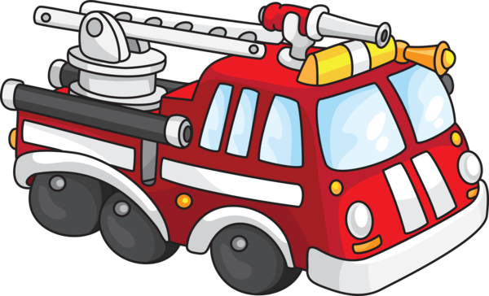
Fireman Relay
- You will need a set of dad’s old clothes (or big boots, pants, and suspenders), a bucket and a log for each team.
- Put blue or white crepe paper streamers 2 to 3 feet long in each fire bucket.
- Players form two teams.
- First player puts on a “fireman’s suit” (old clothes) on top of their own.
- He picks up a bucket and runs to a spot about twenty feet away where a log represents a “fire.”
- He pours the “water” (streamers) on the fire, refills the bucket (replaces streamers), and runs back to their team.
- He takes off their “fireman’s suit” and gives it to the next player. The team that finishes first is the winner.

Fireman, Save My Child
- You will need a drinking straw for each player.
- Cut paper (the children) into squares of various sizes (2” to 4” square).
- The players are divided into two teams.
- Scatter paper squares on a table, about 15 to 20 feet away from the start line.
- Place a container for each team about 10-15 feet from the table (the course is like a triangle).
- On signal, the first player from each team runs to the table with their straw and picks up a square by sucking up the paper against their straw.
- While holding the square this way, each player runs to their respective container and deposits their paper in it.
- If the drop the square on their way, they must stop and pick it up by sucking it up with their straw.
- Run this relay style or set a time limit and let everyone play at the same time. When done count the square pieces in the containers.

Missing Person
The group should be seated in one area, where everyone can see everyone at a glance.
One person selected to be “it” faces away from the group and covers their or her eyes.
Another person is selected to leave the room while all the others quietly leave their seats and take another.
At a signal, “it” turns around and tries to guess who is the missing person while the group slowly counts to ten.
If “it” guesses who is missing before the group finishes counting, then they can have another turn.
Otherwise, another (the missing person?) now becomes “it”.

Rescue Relay
Divide den into 2 equal teams. Supple each Cub Scout with a piece of rope about 2 feet long. One cub from each team sits on a piece of cardboard some distance from the rest of their team. Each Cub must tie rope to their neighbors using a square knot. When all ropes are tied, one end is thrown to the Cub on the cardboard and their team pulls him to safety (pass a line on the ground). First team to pull in Cub is the winner.

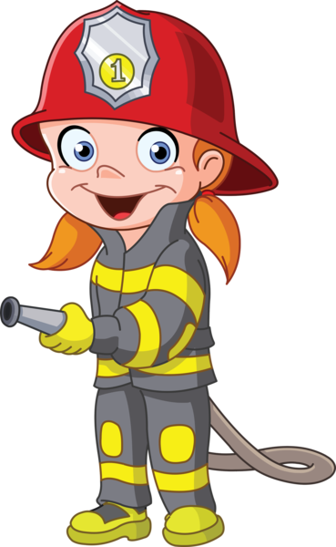

Search and Sketch
This nature scavenger hunt game does not stress collecting, rather Cub Scouts record what they found by sketching pictures of them on paper. Select a safe area with boundaries and set a time limit. Give the Cub Scouts a list of things to find and have them draw it on paper. Here are some sample topics:
- Find two signs of the current season
- Locate four sources of water or air pollution.
- Draw pictures and list what you think can be done about them.
- Find a place to sit for a few minutes, listen to the sounds, then draw what you think might be making the noise.

Role Playing: Fire Fighter
Being a fireman may sound like a lot of fun and excitement, racing down the street in that big truck with the siren blaring. It is exciting but it is also dangerous. Firemen must learn many things before they are ready to start putting out fires, even small ones. Of course, if you are going to play at being a fireman, the first thing you need is a sign for your firehouse.
Take a piece of cardboard (square or rectangle) and draw a fire hose on it. Write "FIRE HOUSE" on it and the number of your choice. Then hang it where you play. Then, there are many other pieces of equipment that a fireman needs.
Let's start with their hat. If you have scissors, paste or glue, different colors of construction paper, cardboard, pencils, paints, crayons, markers you can make a lot of fireman equipment.
For your hat, cut out a large egg-shaped piece from some red construction paper. At the wide end of this piece, mark off two Xs far enough apart so that it will fit on your head. This will probably be an inch or two from the outer edge of the piece of paper. Draw a line from one X to the other, going around the edge of the hat and staying the same distance from the outer edge. Then cut this line and push that area up to form the hat. You can put a yellow shield of your own design, on the front of the your hat, using construction paper and gluing it on.
Now that you have your hat, you will need a pick and an ax, and fire hose.
Pick and Ax: The fireman carries their pick and ax with him when they go into a burning building. Sometimes they must tear down a burning board or break through doors or windows.
To make these important tools you will need some cardboard tube in addition to the other items mentioned earlier.
First cut a large rectangle and a smaller rectangle from the cardboard. Draw and cut out a cone shape on the larger piece and a quarter moon shape on the small one. Cut two deeps slits in one end of two large cardboard tubes. If you have short tubes, you can make them longer using masking tape to tape them together to make a longer pole. You need two poles, one for the pick and one for the ax. Paint the ax and pick heads and the poles with poster paints. When dry, slide the heads into the slits made earlier in the pole. If you put some glue around the slits, it will help to keep the heads in place.
Fire hose: You can also make a fire hose using cardboard tubes and some fabric. Paint your tube #674529. Cut long strips of the same width out of the fabric. Glue these pieces together to make a long strip, and then glue one end of the long strip inside one end of the tube.
Now you have the equipment to put out some big fires.

Role Playing: Police Officer
Police Officers are needed to keep everything under control by seeing that everyone obeys the law. You can make a "Police Station" sign, just like the one for the Fire House, so your friends will know who you are. Then, of course, every officer needs a badge. Make a badge by drawing a crest shape or a shape like a coat-of-arms on yellow paper. Cut it out and write your city on it. Instead of your name on the badge, a police officer has a number, so pick your number and put it right in the middle of your badge. Tape a safety pin to the back of the badge to hold it on.
A police officer needs a hat, too. Cut a narrow strip of blue paper big enough to fit around your head plus a little left over. Place this piece of paper in front of you lengthwise and draw a line with a pencil and ruler about a quarter-inch from the top edge. Then cut evenly spaced slits along this edge, but don't pass the line. Roll the paper strip into a ring and tape it in place. Push the sub slits at the top edge towards the center to make tabs. Put the other end of the ring on a piece of the same color paper and trace around it. Cut out the traced circle. Put some glue on the tabs and place the circle over them to form the hat. Now trace around the bottom again on some #674529 paper. Use a large sheet of #674529 paper because this is going to be the visor for the hat. Mark two Xs opposite of each other on the circle and draw a line outside of the circle connecting the two Xs. Cut out this quarter moon shape and staple or tape the pointed ends to the sides of the hat. You can make a smaller badge like the one you have, to glue onto the hat over the visor.
Handcuffs: Handcuffs come in handy when you are dealing with a really tough guy. Make a circle slightly larger than your wrist. Then cut out another circle about an inch and a half outside of that circle. Cut out the first circle so you have something that looks like a donut. Now cut the donut apart on opposite sides. Take the paper punch and punch holes on both ends of each piece. Use these pieces to trace another "donut". Cut it out. Cut it apart. Punch the holes. Take a string and tie one side of the one set together. Then use the other end of the string to tie one side of the other side together. When you capture the crook, use a paper fastener to push through the holes on the other ends and they won't be able to escape.
Tickets: Cut some white strips of paper, all the same size. Then cut two pieces of colored paper still of the same size for the cover. Staple one end to hold it together and write "TICKETS" on the front cover. When you find someone violating a law, you can write down the offense and the other information about the lawbreaker and give him a ticket.

Spinning Wheel
Players sit in a circle on the floor with their legs stretched out in front of them and their feet touching. Players lean back on their hands, which they have placed behind them,
and wait until the leader says, “Turn!” Then everyone moves to the right at the same time. To keep the wheel intact, everyone must turn together. If a player moves too slowly or too quickly, a pileup may happen and someone can yell: “Flat!” Players try to make the most consecutive turns as possible, although the fun is in the effort, not the outcome.

Telephone Code
This is a secret message game based on the telephone. Give each Cub Scout a pencil and paper and ask him to convert a very short message into code based on the dial numbers.
Decoding can be tricky, since there is more than one letter for each number.
Here is a sample message:
DO: 36
YOUR: 9687
BEST: 2378
When each Cub Scout has encoded their message, exchange papers and have the Cub Scouts try to decode each other’s messages.

Tug of Peace
A group of Cub Scouts sit in a circle holding onto a rope placed inside the circle in front of their feet. The ends of the rope are tied together to make a huge loop. If everyone pulls at the same time, the entire group should be able to come to a standing position. The Tug of Peace can also be played by stretching the rope out straight and having Cub Scouts sit on either side of it, facing each other in two lines. If both sides pull on the rope evenly, they can help each other up.

Where's the Fire Alarm?
One Cub Scout stands with their eyes blindfolded in the center of a circle formed by the other Cub Scouts.
The center counts aloud to 20. At the same time the other Cub Scouts pass a small bell around the circle, ringing it as it travels.
When the counter reaches 20, all the Cub Scouts in the circle put their hands behind their backs.
The Cub Scout in the center takes off the blindfold and tries to guess who has the alarm - the bell.
The Cub Scout in the center has three guesses; if they guess correctly, the Cub Scout who held the alarm comes into the center. If not, the counter is blindfolded again, counts to 20 and the game continues as before. No Cub Scout should be permitted to remain in the center of the circle for more than 2 or 3 turns. Remember: The Cub Scout in the center can turn as the bell rings so they should listen carefully.

Who Done It? Round Robin
This is an activity that the kids love. Set up a “Who Done It” mystery scenario and then have different “tables.”
The Cub Scouts visit the tables to gather clues to solve the mystery.
For the event, try to also arrange for a local police officer to come in at the end of the activity to ask the Pack for help in solving the crime.
Of course, the event is set up so that all clues point to the Cubmaster.
The officer hand-cuffs him/her and then the Pack could take up a collection to make bail. (Donate proceeds to a worthy cause or use for a Service Project for your Chartered Org)

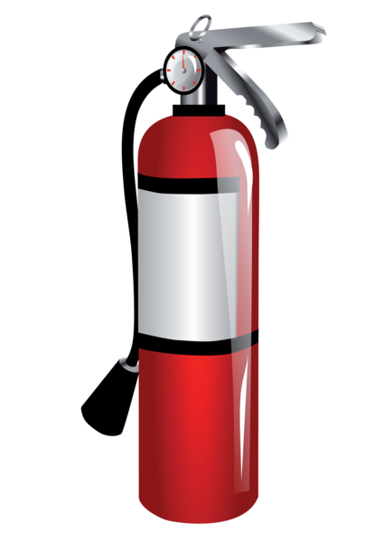

Who Dunnit?
Before starting the game, explain the way it is played to all the Cub Scouts. Each Cub Scout will have a turn at playing the Detective. That Cub Scout will leave the room and another Cub Scout will be selected as the one “Who Dunnit.” All of the Cub Scouts left in the den area (including Who Dunnit) will come up with a one-phrase clue to give the Detective when they return. The clues should not be so obvious, as the Cub Scout’s name, but should be fairly unique to Who Dunnit. For example, it might be the Cub Scout’s street name (Oakmont Road) or color of eyes (blue eyes) or family (three sisters). Based on the clues, the Detective tries to guess Who Dunnit. To identify Who Dunnit, the Den Leader should select one Cub Scout randomly (so there’s no order to who is selected for each turn).
Who Is Missing?
Equipment: None
Formation: Circle
The Cub Scouts walk round in a circle. When the leader gives a signal they all cover their eyes with their caps or their hands. The leader touches one of the Cubs on the shoulder and they leaves\ the room as quickly and as quietly as possible, while the others still walk with their eyes closed.
When the leader calls 'STOP!', the Cub Scouts stop walking and uncover their eyes. The first one to give the name of the Cub Scout who is missing, is the winner. Note: The Cub Scouts should not walk round for too long a time, as they will become dizzy. Watch out for any Cub Scouts who are cheating by peeping through their fingers!
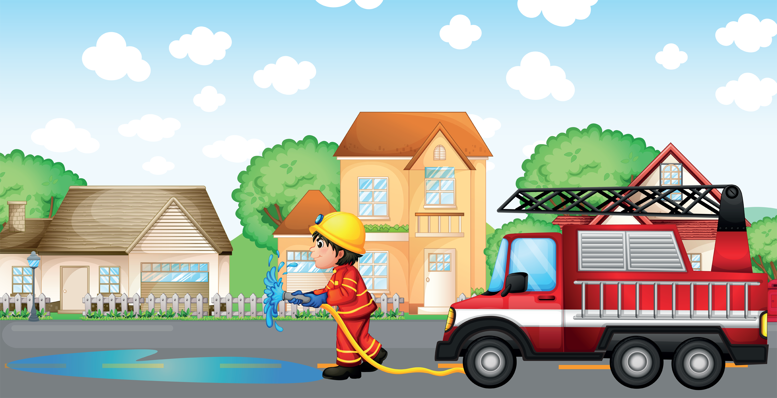
X Marks the Spot
This is a simple game that can be used to choose “It” for another game. All of the players stand on one side of the room touching the wall with their back. Have a Den Leader supervise this game.
The leader points out a spot on the ground, for example, a seam between two floor tiles. The players close their eyes and take turns walking slowly toward the spot, relying on their memory to judge its location.
When the player believes they are on the spot, they stop and sit down. Players must remain sitting until everyone has sat down. Whoever is closest to the spot is the winner. For an added challenge, turn off the lights after the spot has been chosen.

GATHERING ACTIVITIES

Fire Safety Quiz
1. What should you do to be ready if fire should strike your home?
  - a. Keep pails of water handy.
  - b. Have an escape plan and rehearse it often.
  - c. Be ready to carry out furniture.
  - d. Have a suitcase already packed.
2. In making your escape plan, why should you know two ways out of every room?
a. So I can see different parts of the house when I practice.
b. In case fire or smoke blocks one escape route.
c. To keep people guessing.
d. To make home fire drills more fun.
3. If your clothing catches fire, what do you do?
a. Run for help.
b. Look for water to throw on yourself.
c. Roll on the floor or ground, wrapping yourself in a coat, blanket, or rug, if possible.
d. Try to blow out the fire.
4. What should you use for light in a dark closet where there is no light bulb?
  - a. A match.
  - b. A candle.
  - c. A cigarette lighter.
  - d. A flashlight.
5. When you check extension cords in your home for fire hazards, what should you look for? Choose 2.
  - a. Frayed, broken insulation.
  - b. Whether the color matches the woodwork.
  - c. Whether they run under rugs.
  - d. Whether the plug is brown or white.
6. If there are small children in your home, you should be especially careful that they cannot play with which of these?
  - a. Pile of blankets
  - b. Matches
  - c. Tennis Balls
  - d. Pots and Pans
7. In checking around a furnace for fire hazards, you should remove which of these?
  - a. Fishing rods and reels.
  - b. Table.
  - c. Garden Tools
  - d. Gasoline can, greasy rags, newspapers
8. Stairways in your home should be:
a. A great place to play.
b. A good place to keep your toys when you aren’t playing with them.
c. Kept clear of obstructions at all times.
d. A place to pile your laundry until you can take it to your room.
Answers: 1-b, 2-b, 3-c, 4-d, 5-a-c, 6-b, 7-d, 8-c

Follow the Clues
This activity will take a little time to put together and has to be based on where you will meet when you run the activity. List out a bunch of things that are in the meeting place and a clue as to what each
is. Depending on the Cub Scouts’ level, you can make the clues appropriately hard/easy.
For example:
- Den Flag – Blue cloth with Number 4 on it that says what our Cub Scout group is.
- American Flag – A flag that stands for the nation.
- Advancement Poster – Where we track how well you are doing learning new things and completing activities.
- Craft Table – Where we gather to make special items with glue and paper.
- Supplies Box – Where the Den Leader stores materials for the Den Meetings
- Stairs – The up & down machine you used to get to the basement.
- Good Conduct Candle – What should stay shining bright throughout the meeting.
- Main Door – The entry way to the meeting.
Write out the clues on separate index cards (or inside folded sheets of paper) and attach each clue to an object to which the clue doesn’t refer. (In other words, don’t put the den flag clue on the den flag).
As each Cub Scout arrives, give them a sheet of paper with a starting point for then to follow the clues.
Explain that at the starting point they will find a clue to another object in the room and that they are to go to that object, write down what it is, and then follow the new clue at that object to get to the next one until they have followed all of the clues that lead back to the starting point.
After the opening ceremony, have the Cub Scouts take turns reading off the objects to which the clues led them until all of the objects have been identified.

INVOCATIONS

“Thank you for our leaders who teach us what to do in an emergency and for the willingness to be helpful to others.”

OPENING CEREMONIES

Cub Scout Crime Prevention Tips
Have six Cub Scouts with cards depicting various rescue items – police cars, fire trucks... and words on back in large letters. Have another Cub Scout or a leader lead the Pledge of Allegiance when Cub Scouts are done.

# 1: To help make things safer, we offer these tips. On everything from school to going on trips.
# 2: Make sure that you know your full name and phone number. So, if you should need them you don’t stop and wonder.
# 3: Learn from your parents where you’re safe to go. That way if you’re walking, which way they will know.
# 4: Be alert in your neighborhood and note what you see. Tell an adult if you think “It didn’t look good to me.”
# 5: Don’t let your feelings get you in a fight, Make friends or walk away whether you’re wrong or right.
# 6: And finally, remember, put safety number one. So, no one gets hurt and all will have fun.

Dial 911
Characters: One older Cub Scout dressed in full uniform with neckerchief tied loosely like a cape. Six younger Cub Scouts with their den leader
Setting: A den meeting teaching the younger Scouts
DL: It is important to know when to dial 911. What do you know about 911?
# 1: You only call it in an emergency.
# 2: What is an emergency?
Older CS: (Jumps on stage and stands with hands on hips like Superman) Cub Scout to the rescue! You call 911 for emergencies you or your family can’t handle. (Pretends to fly off the stage)
# 3: What kind of emergency can my family not handle?
Older CS: (Jumps on stage and stands with hands on hips like Superman) Cub Scout to the rescue! Like, your house smells like natural gas, or it is on fire. If someone is really hurt, not breathing, or needs an ambulance. (Pretends to fly off the stage)
DL: Wow that Cub Scout knows their stuff. What do you say to the 911 operator?
# 4: I’m not supposed to talk to strangers.
Older CS: (Jumps on stage and stands with hands on hips like Superman) Cub Scout to the rescue! That’s true, but the 911 operator is there to help you. Go ahead and tell them your name. (Pretends to fly off the stage)
# 5: Then I hang up, right?
Older CS: (Jumps on stage and stands with hands on hips like Superman) Cub Scout to the rescue! No, you tell them what the emergency is and where it is. It is a good idea to know your address if the emergency happens while you are at home so they know where to go. (Pretends to fly off the stage)
# 6: Now I hang up?
Older CS: (Jumps on stage and stands with hands on hips like Superman) Cub Scout to the rescue! No, you will need to stay on the line until help arrives, speak clearly, and answer all the operator’s questions. (Pretends to fly off the stage)
DL: He’s right! Dial 911 only for emergencies; tell the operator what the emergency is and where it is. Tell them your name, answer all their questions, and stay on the line until help arrives.
All: Scouting can teach us how to come to the rescue, just like that Cub Scout.
CM: Thank you! Will Den come to the rescue and present the colors?
Fire Brigade Opening
A brigade of Cub Scouts dressed as fire fighters come running out on stage as if responding to a three-alarm fire. On stage is a ladder and taped to the sides are flames and billowing puffs of smoke cut from poster board or cardboard. On the reverse side of each flame and cloud of smoke is text describing a particular household fire hazard and means for preventing it. One by one, the Cub Scouts mount the ladder, remove a card, climb back down and read the text to the audience. Follow with a flag ceremony.

Fire Safety Opening
Setting: The room lights are turned off. The Cubmaster lights a candle.
Cubmaster: Cub Scouts, this candlelight represents the spirit of Cub Scouting, lighting our way through life. This flame also represents danger. As fire detectives, you have learned about the danger of fire and how to prevent it. Let’s remember what we have learned so we will always use fire wisely and safely, not only today but the rest of your life. This light of Cub Scouting gives us warmth and good cheer. Make sure it is never allowed to run wild and destroy lives and property. Let’s always be fire detectives. (Lights on. Have a Webelos den post the US flag and lead in the Pledge of Allegiance.)

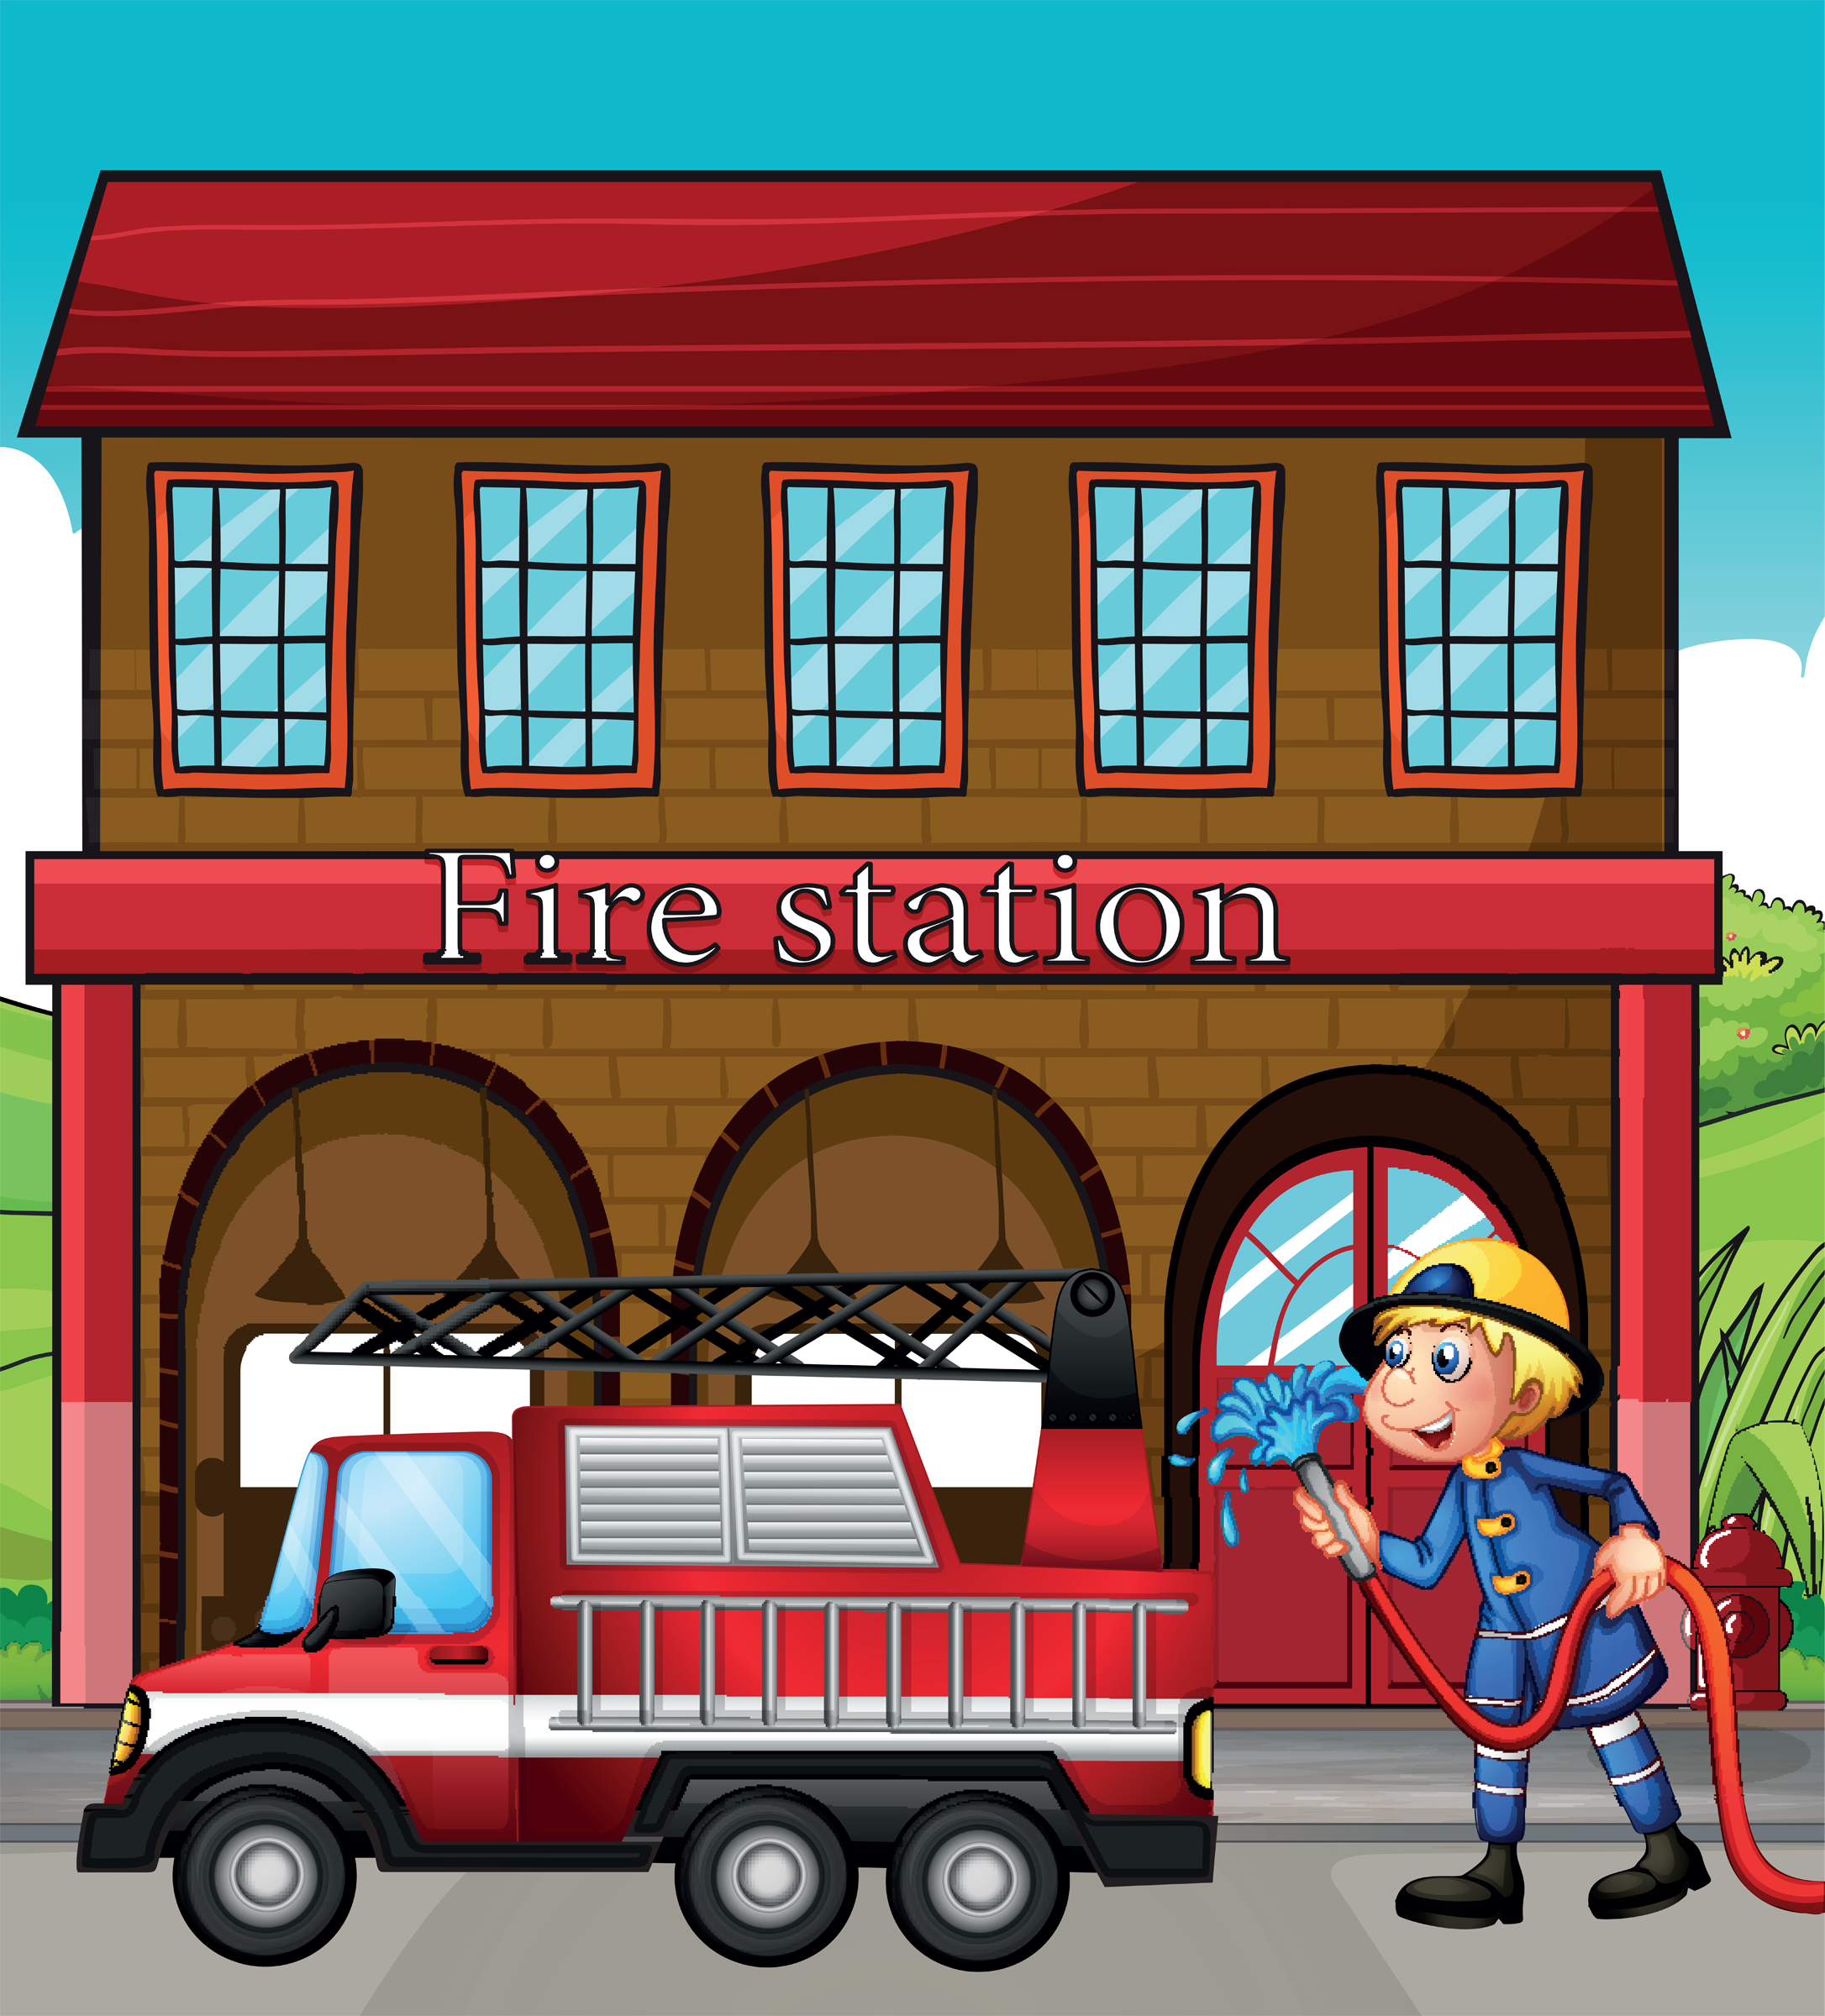
Hometown Heroes
You will need 6 Cub Scouts. Have each Cub Scout make up a card with a picture illustrating what the words on their card say or anything he wants related to the theme. Make sure the words are in large print.
# 1: Sometimes a local hero is obvious, the policeman who risks their life to protect us from violence or the fireman who pulls people out of burning buildings.
# 2: Other heroes that come to mind are the ambulance drivers, paramedics, doctors and nurses who save lives everyday.
# 3: Some people around us seem like regular people, but they are heroes because they used to be soldiers in the military and served our country to keep us free.
# 4: A hero is someone who does the right thing even when they are afraid of failure. They do it because it should be done.
# 5: Some heroes are harder to spot, but they are still there. My heroes include the people who donate blood, teachers who spend their time and energy helping kids, and kids who say “No” to drugs.
# 6: Heroes are all around us. Please join in saluting all the heroes of our country, by repeating with me the Pledge of Allegiance to the Flag.

How to Dial 911
Narrator: It is important to know how and when to Dial 911. Our Cub Scouts want to share what they have learned about using 911.
# 1: Always be prepared for an emergency. Know where the closest phone is.
# 2: To Dial 911, pay phones are free.
# 3: Know what is wrong, what’s the emergency.
# 4: Know where you are, the address and street.
# 5: Say who you are and
# 6: Tell them who needs help.
# 7: Speak clearly and answer questions.
# 8: Stay on the line until help arrives.
All: Dial 911 only for an emergency.

When to Dial 911
Cub Scouts enter one by one with signs reading Dial 911.
# 1: Our Den Leader taught us to “Do our best” and know when to (holds sign up) Dial 911.
# 2: When someone's hurt in an emergency (holds up sign). Dial 911.
# 3: A house on fire is an emergency (holds up sign). Dial 911.
# 4: Smell gas or smoke, it’s an emergency (holds up sign). Dial 911.
# 5: Need an ambulance, that’s an emergency (holds up sign). Dial 911.
# 6: Power line is down - it’s an emergency (holds up sign). Dial 911.
# 7: Choking on food or not breathing is an emergency (holds up sign).Dial 911.
# 8: Fallen in the water and cannot swim can be an emergency (holds up sign). Dial 911
All: Join all of us to ‘Do your Best’ - Dial 911 in an emergency.

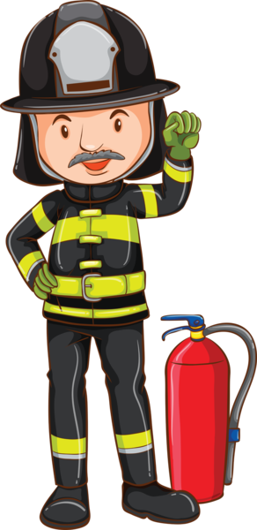

RUN-ONS

Run-Ons

#1: "Hey look over there, smoke signals."
#2: "Oh yes, what do they say?"
#1: (pretending to look away through binoculars says very slowly) "Help... My... Blanket… is... On... Fire.
#1: (looking back at 2nd Cub) "Help, my blanket is on fire?"
#2: Who can hold up traffic with one hand?
#2: A policeman.

SKITS

C.P.R.
Scout comes out walking around, they suddenly grabs their chest and falls to the ground.
Two other Scouts come in talking about just completing their first aid merit badge and find the Scout on the ground.
They rush to their aid and begin C.P.R. Adjust the head, listen, feel for pulse then begin fake compressions.
The other Scout counts.
After about 3 sets, the other Scout yells “SWITCH”.
Suddenly, the Scout on the ground gets up, one of the other two Scouts lies down, and they begin again to administer C.P.R.

Doctor! Doctor!
The secret to success with this series of quickies is to keep them moving along. You can have one doctor and different patients, but it may add greater rush and flurry if a different doctor and patient fly in and out for each quickie.
#1: Doctor! Doctor! I feel like a set of drapes.
Doc: Pull yourself together!
#2: Doctor! Doctor! Am I going to die?
Doc: That's the last thing you'll do.
#3: Doctor! Doctor! Everyone is ignoring me.
Doc: Next!
#4: Doctor! Doctor! My back feels like a deck of cards!
Doc: I'll deal with you later.
#4: Doctor! Doctor! What's wrong with me?
Doc: Have you had this before?
#4: Yes.
Doc: Well, you've got it again!
Doc: You'll live to be 80.
#5: I am 80.
Doc: See!
#6: Doctor! Doctor! I've got insomnia.
Doc: Don't lose any sleep over it!
#7: Doctor! Doctor! My Cub Scout swallowed a pen!
Doc: Well, bring him to my office as soon as you can.
#7: What should I do in the meantime?
Doc: Use a pencil.
Doctor's Office
First patient comes in hiccupping and asks to see the doctor. The second patient comes in cross-eyed, with a silly look on their face.
The third person can't control their muscles and is all jittery. They are all asked to sit down.
The first person is asked to go in. There is a real commotion and the patient comes out fine. The same thing happens to the second and third patients. The nurse tells the doctor it is time to go home. The doctor emerges with the symptoms of all their patients and goes offstage.

Emergency Alert System Skit
This skit requires six to 10 Scouts. Make sure you practice so the “Beeeeeps” start and stop when they should and so the punch line doesn’t drag on too long.

All Scouts but one stand in line. The lead Scout is in front or to one side.

Lead Scout: “For the next 10 seconds, we will conduct a test of the emergency broadcast system.”

(The line of Scouts all make a “Beeeeeeeeeeep” sound until the leader raises their hand.)

Lead Scout: “Thank you. This concludes our test of the emergency broadcast system. Had this been an actual emergency, you would have heard . . .” (Scouts scream in panic and run around.)

The Fire
You need two players and a behind-the-scenes person to move the fire (an artificial campfire with almost invisible strings attached).
The players sit by the fire, reading, doing a puzzle, etc. The fire moves slightly. They don’t notice.
It moves again. They don’t notice.
This continues until the fire is pulled off stage.
At that point, one of the players looks at the other and says,
“Looks like the fire’s gone out again!”

Fire Safety Skit
Set Up: This skit needs at least five Scouts.
Mr. James and Narrator wear suits or shirt and ties. Hose person carries a garden hose,
Ladder person carries a chair,
Chief wears a fire hat and raincoat.
Other props are a candle and matches, and an offstage siren. (One of the Scouts can make the siren noise, as Cub Scouts seem to do this so well.)
Narrator: Now, this evening, folks, we have Mr. James to talk to us on fire safety. Let’s welcome Mr. James. (Narrator begins applause, audience follows.)
Mr. James: Hello, ladies and gentlemen. This
evening I would like to discuss the hazards of an unwatched open flame. I shall light this candle now as the first part of my demonstration.
(Mr. James lights candle. Just as he is about to open his mouth to begin his talk a siren goes off.)
Hose man: (enters shouting) Fire! Fire! Fire!
(Ladder person enters and sets up chair next to Mr.
James. Others may also enter, adding to the excitement,
All Firemen (Shout) Chief! Chief! Chief! Fire!
Fire! Fire!
Chief enters and climbs chair, he ceremoniously blows out the candle. All firemen run off stage
Narrator: That concludes our fire safety
demonstration. Thank you, Mr. James. (Shakes Mr. James’ hand.) I’m sure we’ll all remember that an unwatched open flame can cause a lot of trouble!
Narrator exits, Mr. James picks up candle and exits singing “Happy Birthday”.

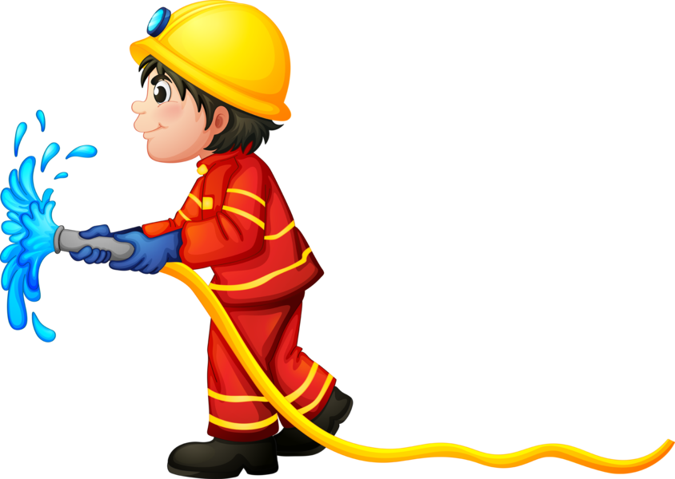

Fire Starting
Characters: Eight Cub Scouts
Props: See what each Scout needs in the skit.
[Have each Scout walk on stage with their prop, say their line, and build a fire.]
# 1: (holding wood shavings, pine needles, dry grasses, shredded bark, etc) I’m tinder! I’m quick to burn because I’m small and dry!
# 2: (holding pieces of firewood) I’m kindling! I’m dry dead twigs no thicker than a pencil.
# 3: (holding pieces of firewood) I’m fuel! I’m dry dead wood as thin as your finger and up to as thick as your arm.
# 4: (holding a big cardboard match) I’m a match! I create a spark which will ignite the tinder.
# 5: (holding a poster board picture of a small flame) I’m a flame! I start the kindling burning.
# 6: (holding a poster board picture of a medium fire) I’m a blaze! I burn the fuel and give off heat and light.
# 7: (holding a poster board picture of roaring fire) I’m a bonfire! I’m very dangerous. I can give off enough heat to make this whole pack hot.
# 8: (holding a pail with a small mist bottle of water hidden inside) I’m water. I can put out fires and cool you off. (Takes spray mist bottle out of pail and lightly sprays it into the air.)

Why Are Fire Engines Red?
You will need 7 Cub Scouts each with a picture of a fire engine to hold.
# 1: Why are fire engines red? Well. Roses are red too.
# 2: And two and two are four. Four and eight are twelve.
# 3: There are twelve inches in a ruler. Now Queen Mary was a ruler.
# 4: Queen Mary was also a ship. Ships sail on the sea.
# 5: Fish swim in the sea. Fish have fins.
# 6: The Finns fought the Russians. The Russians were red.
# 7: Fire engines are always rushin’. And that’s why fire engines are red.

SONGS

9-1-1 HELP
Tune: My Bonnie

Emergencies they will answer,
They’re always a phone call away
They come when they’re needed most promptly
And for you they will most surely stay
Chorus:
Nine-one-one
Nine-one-one
We call on them when we need HE…LP

Medics are your friends and my friends
They answer their calls so fast
They come when they are needed so greatly
And always will stay to the last.
Chorus:
The firemen too answer calls
A fire is scary to see
But when they come oh so quickly
They put out the fire with glee
Chorus:
We often need a policeman
And 9-1-1 will get one there
Be sure that you know your address
Of this you should always be aware
Chorus:

Dial 911
Tune: Three Blind Mice
Dial 911
Dial 911
If you are hurt
If you need help
If someone has fallen and can't get up
Run to the phone and pick it up
Stay on the line and don't hang it up
Help will come.
5. say “the end”.
Emergency Call
Tune: Are You Sleeping?

Someone’s crying,
Hurt and crying
911, 911
Tell them your location,
Stay calm and be patient
911, 911

Fireman’s Song

Behold the noble Firefighters, all dressed in red and black.
They climb the tilted ladder with a rope upon their back.
An axe they carry by their side, a helmet on their head,
They go to fight the fire, most powerful and dread.
They are our unsung heroes, these people brawn and might,
And to watch them fight a fire is a great and wondrous sight.

Fire Prevention
Tune: Clementine

Check your hallways, check your closets,
And underneath the stairwell, too.
For if you’ve piled lots of junk there,
A big fire may call on you.

Dirty paint rags, piled up papers,
Frayed extension cords won’t do.
Fire prevention is the answer,
All Cub Scouts must follow through.

I Wish I Were A Volunteer
Tune: Oscar Meyer Weiner

Oh, I wish I were a volunteer fireman,
That is what I’d really like to be.
‘Cuz if I were a volunteer fireman,
Everyone would look up to me.
I’d climb a ladder up high to save babies.
I’d battle fire, smoke and burning steam.
I’d wear my big, red fireman’s cap proudly,
And polish my badge until it gleamed.
I’d rescue cats from limbs in very tall trees
And do inspections very carefully,
I’d teach the kids to all be fire detectives
‘Cuz then my job would be so easy
London’s Burning (A Round)

London’s burning London’s burning,
Look yonder, look yonder,
Fire, fire! Fire, Fire! And we have No water.

Old Macdonald’s Fire
Tune: Old McDonald Had A Farm

Old MacDonald had a farm, E-I-E-I-O.
And on this farm he had some woods, E-I-E-I-O.
With a chop-chop here, and a chop-chop there,
Here a chop, there a chop,
Everywhere a chop-chop.
Old MacDonald had some woods, E-I-E-I-O.

Then Old MacDonald lit a match, E-I-E-I-O.
And he was careless burning trash, E-I-E-I-O.
With a spark-spark here, and a spark-spark there,
Here a spark, there a spark,
Everywhere a spark-spark.
Old MacDonald burned his woods, E-I-E-I-O.

(Sing this very slowly)
Through carelessness, he burned his woods, E-I-E-I-O.
Now, Old MacDonald has no woods, E-I-E-I-O.
With a ash-ash here, and a ash-ash there,
Here an ash, there an ash,
Everywhere an ash-ash.
Old MacDonald has no woods, E-I-E-I-O.

Prevent Fires
Tune: Are you Sleeping?

Prevent fires, prevent fires,
Do your part, do your part,
Check your house for hazards,
Check your house for hazards,
You’ll be smart. You’ll be smart.

Hunt for hazards, hunt for hazards,
Clean them out, clean them out.
Help protect your family,
Help protect your family,
Have no doubt, have no doubt.

Thinking Safety
Tune: Clementine

In the kitchen, Dad was cooking,
Frying chicken in some oil.
Said he’d go out to do the shopping,
Just as dinner tried to boil!

Thinking Safety, I remembered,
Told him, “Dad! Turn off the heat!”
Using caution is more important
Than preparing supper meat.

At the table was a candle
Mom had lit to cheer the room.
Matches sitting on the counter
Made me feel a sense of doom.

Thinking Safety, I remembered,
Told her, “Mom, this I must teach,
Keep the matches and the lighters
Out of little sister’s reach!”

In the bedroom, brother studied,
Working oh so diligently,
Stereo, TV, heater, computer,
All plugged in the same circuitry.

Thinking Safety, I remembered,
Told him, “Bud, that’s not too wise!
You should unplug some electronics
Before that one connection fries!”

Fire prevention can be easy,
Just have care at every turn.
Use your good sense and some planning
To prevent unwanted burn.

