Build It Up, Knock It Down
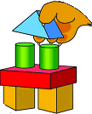
Parent and Leader Guidebook: page 66
Lion Adventure Book: page 15

Materials
- Copies of King of the Jungle handout, one per adult
- Copy of Den Meeting Plan, one for leader(s)
- Name tags and Sharpie
- Cub Scouts Poster Set with Scout Law, Scout Oath and Den Code of Conduct (#621086 from Scout Shop)
- Blue tape or something to hang posters on wall
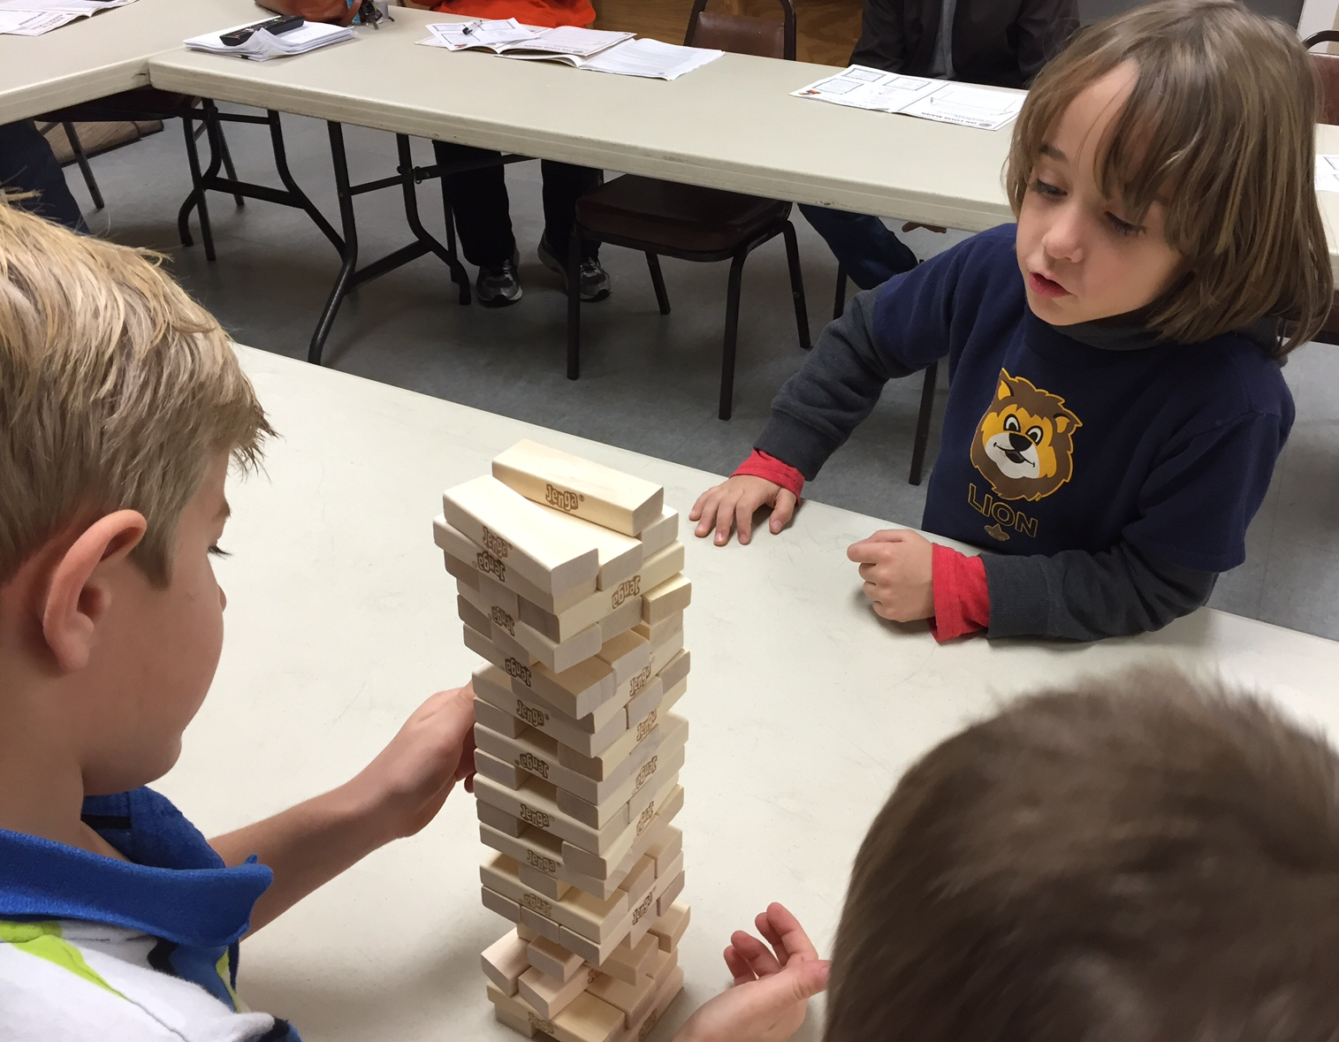
Optional
- Snack and water
- Activities for siblings (e.g., coloring books)

Activity 1: Building Imagination
- Building materials (e.g., empty cans, cups, paper/plastic plates, toothpicks, straws, chenille stems, dominoes, blocks, building boxes)
- Tape
- Team building game with stacking blocks (e.g., Jenga)

Activity 2: Cub Stack Relay
- 12 large cups or cans that can be stacked as a pyramid (24 or 26 for large groups)
- Small ball (foam or other soft material)

Activity 3: Bucket Brigade (outside)
- 4 water bottles (2 full and 2 empty)
- Bathroom-sized cups, one per Scout

Activity 3: Meeting #2: Basic Bubbles
- Bubbles
- Various wands (e.g., store bought, pipe cleaners, several straws taped together, bubble blower (plastic cup with hole poked for straw about an inch up, straw), 2 straws with a piece of string thread through the straws with a knot tied, hangers bent in shapes.
- Super Strength Bubble recipe: 6 c. water, 1 c. light corn syrup, 2 c. clear dishwashing liquid
- Containers for bubbles
- Paper towels

Activity Wrap Up
- Colored pencils, crayons or markers
- Few extra copies of Lion Adventure Book page 15 (for those who forget book).

Closing
- Colored pencils, crayons or markers
- Nametags (mailing labels, sticky notes, or tape)

Den Meeting Plan
Build It Up, Knock It Down

Gathering
- Shadow Tag

Opening
- Good conduct candle
- Pledge, Scout Oath, Scout Law
- Give a big Lion Roar!

Talk Time
- Den business
- Sharing time

Activities
- Activity 1: Building Imagination
- Song
- Activity 2: Cub Stack Relay
- Activity 3: Bucket Brigade
- Bubbles

Closing
- Review: how we can build things up and how easily we can tear them down
- Lions (with help from adult) recognizes a fellow Lion
- Scout Law

Build It Up, Knock It Down Adventure

Build, Build, Build
Tune: Row, Row, Row Your Boat

Build, build, build a tower,
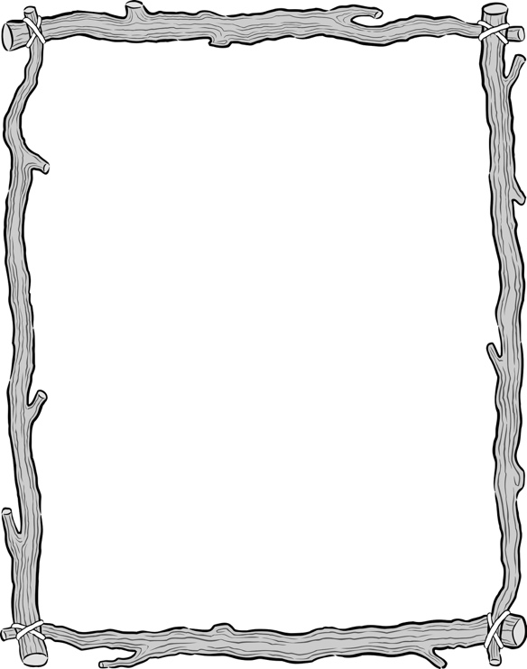
Build it up so high;
Reaching, climbing, growing tall,
Almost to the sky.
Scout Law
A Scout is trustworthy, loyal, helpful, friendly, courteous, kind, obedient, cheerful, thrifty, brave, clean, reverent.
Scout Oath
On my honor, I will do my best to do my duty to God and my country and to obey the Scout Law; to help other people at all times; to keep myself physically strong, mentally awake, and morally straight.

Knock, knock, knock it down,
Lay the wall out flat;
Now you see it, now you don’t,
It tumbled and went splat!
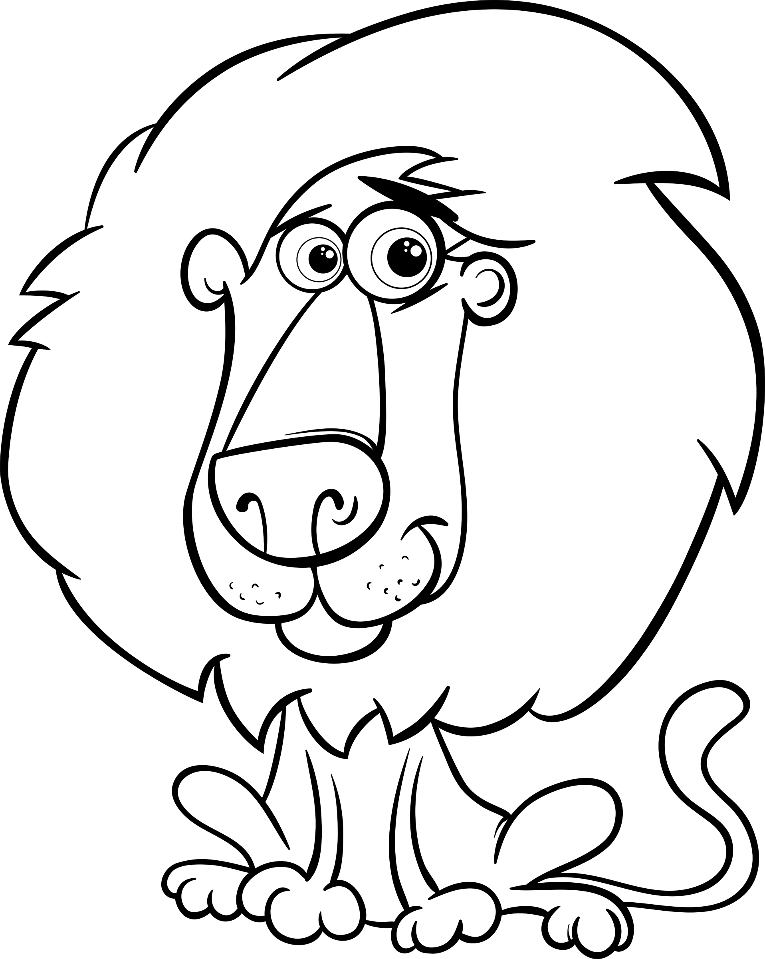

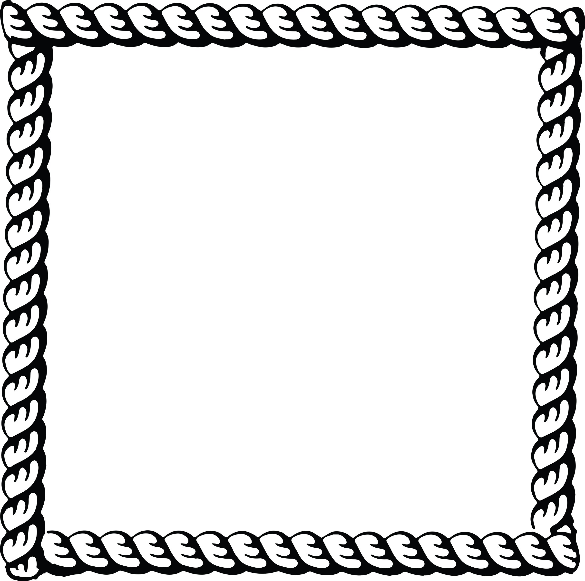
Upcoming Events

Jan 27 Scouting for Food
Jan Outing (TBD)

Feb 7 Den Meeting
Feb 12 Check-in derby car
Feb 24 Pinewood Derby
Feb 28 Pack Meeting

Mar 7 Den Meeting
Mar Outing (TBD)
Mar 24-25 Family campout (optional)

Apr 14 Scout Fair
Pack 72
facebook.com/pack72tomball
pack72tomball.scoutlander.com
Orion District
www.orion.shac.org
facebook.com/orionbsa
Sam Houston Area Council
www.shac.org
facebook.com/shac.bsa
Bubble Ideas

Take two drinking straws and a section of yarn about 6 times the length of the straw. Thread the yarn through the straws and tie a knot.

Pipe cleaners.

Bubble Blower: Plastic cup and straw. Poke a hole in the cup about 1” from the bottom. Insert straw into the hole. Pour ¾” of bubble solution. Blow bubbles.

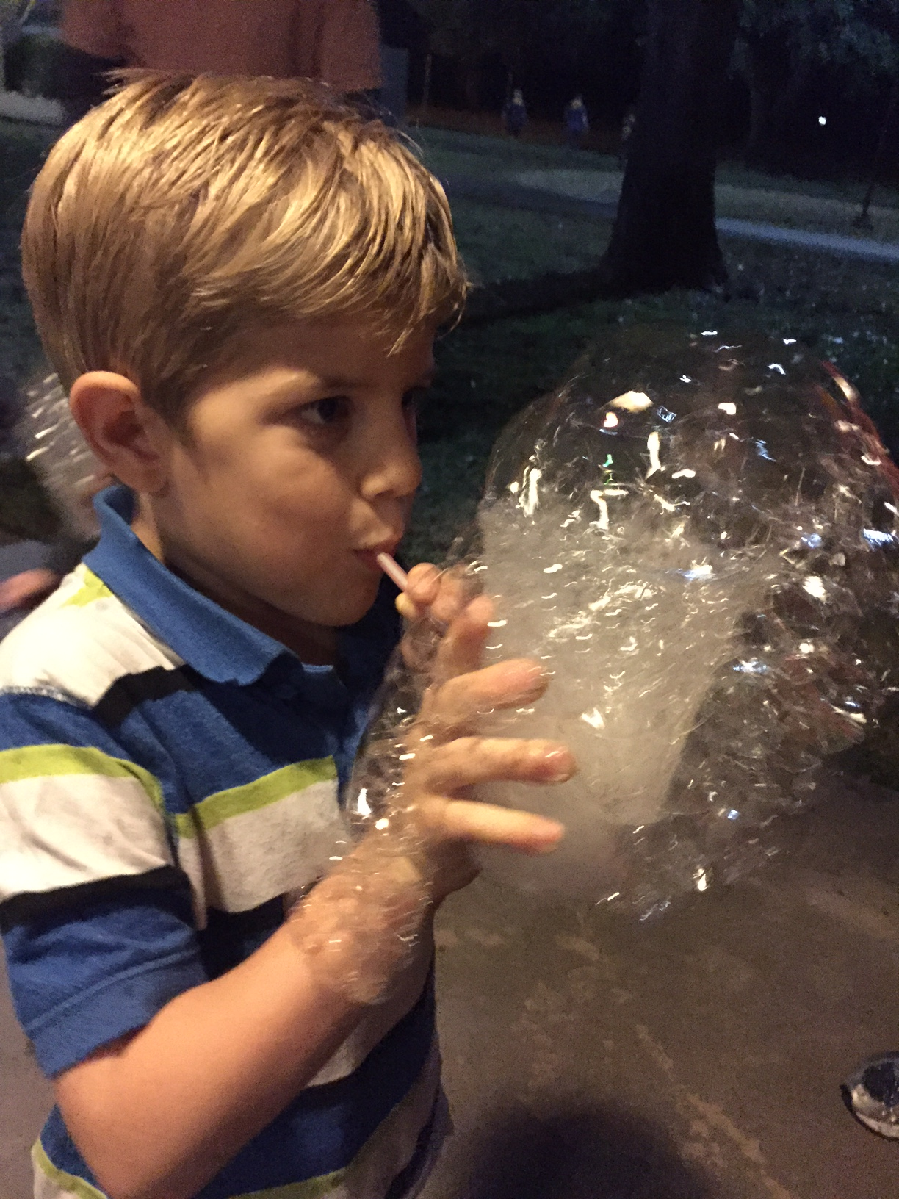

The Science Behind Bubbles
www.kidsdiscover.com/teacherresources/bubbles-for-kids/

What’s the science behind (or inside) a bubble? Bubbles provide the opportunity to study science concepts such as elasticity, surface tension, chemistry, light, and even geometry. Your students can engage in processes such as observation, experimentation, investigation, and discovery, simply by studying bubbles.

Talk about what makes a bubble. A bubble is just air wrapped in soap film. Soap film is made from soap and water (or other liquid). The outside and inside surfaces of a bubble consist of soap molecules. A thin layer of water lies between the two layers of soap molecules, sort of like a water sandwich with soap molecules for bread. They work together to hold air inside.

Create a bubble that stretches out using a large wand (that you can make from a piece of wire). Whoosh it through the air so that the bubble follows and grows behind it. Then, with great drama, let the bubble go. Give the students a chance to note what happens to it before it pops. Why is a bubble round? Bubbles can stretch and become all kinds of crazy looking shapes. But if you seal a bubble by flipping it off your wand, the tension in the bubble skin shrinks to the smallest possible shape for the volume of air it contains. That’s why even if it had a goofy shape before you sealed it, once sealed shut, the bubble will shrink into a sphere shape. Compared to any other shape, a sphere has the smallest surface area for the amount of volume.

Blow several bubbles and have the students blow and fan them to keep them from landing. The object here is to watch them pop without obvious interference. And it’s a bit of fun for everyone. Why do bubbles pop? Other than being poked or landing on something sharp, bubbles pop when the water between the soap film surfaces evaporates. To note, when it’s cold, those molecules take longer to leave. If you blow a bubble on a calm winter day, a bubble can even freeze and last for several minutes before it wisps away. Also, the colder the outside temperature is, the higher a bubble might fly. That’s because the warm air from your breath is lighter than cold air.

Blow more bubbles and ask a few students to study them close-up. What do they see? Is a bubble really transparent, or do bubbles have colors? Can they see their faces in the bubbles? A bubble gets its color from light waves reflecting between the soap film’s outer and inner surfaces. The distance between the layers gets smaller as the water evaporates, making the colors change. Bubbles can also reflect what’s around them, like the faces peering at them.

Blow several bubbles with a straw so that you have a three of them stuck together – this might take practice!
Why do bubbles stick together? Since a bubble tends to minimize its surface area, bubbles will join together to share one common wall. Three bubbles will meet at the center, always at an angle of 120 degrees. This is not as easy to set up, but not that difficult and a very cool experiment: use two sheets of clear plastic that are about a half inch apart. You could put one sheet on a table and prop up the second with thin blocks. Soak the sheets in a bubble solution, place them, and then blow bubbles between them. When bubbles are about the same size, they form perfect hexagons. Bees do the same thing when they build a beehive. Bees, like bubbles, are also very efficient with their spaces. They use the minimum amount of wax to create their spaces.

Your Grand Finale: Set the lid of the bubble container on a table and fill it with bubble solution. Dip a straw into the container so it is moistened by the solution, and blow a bubble on the lid. Then draw out the straw. Magic! Next, dip the pointed ends of a pair of scissors in the solution. Poke them through the wall of your bubble. Let the kids try poking other stuff that has been moistened in the solution, even their fingers. You can then poke your straw back inside the bubble and blow another bubble. By now, you should be super awesome in their minds. Why didn’t the bubble pop? The bubble just wraps itself around anything that is wet, filling in the hole that would have been made.

