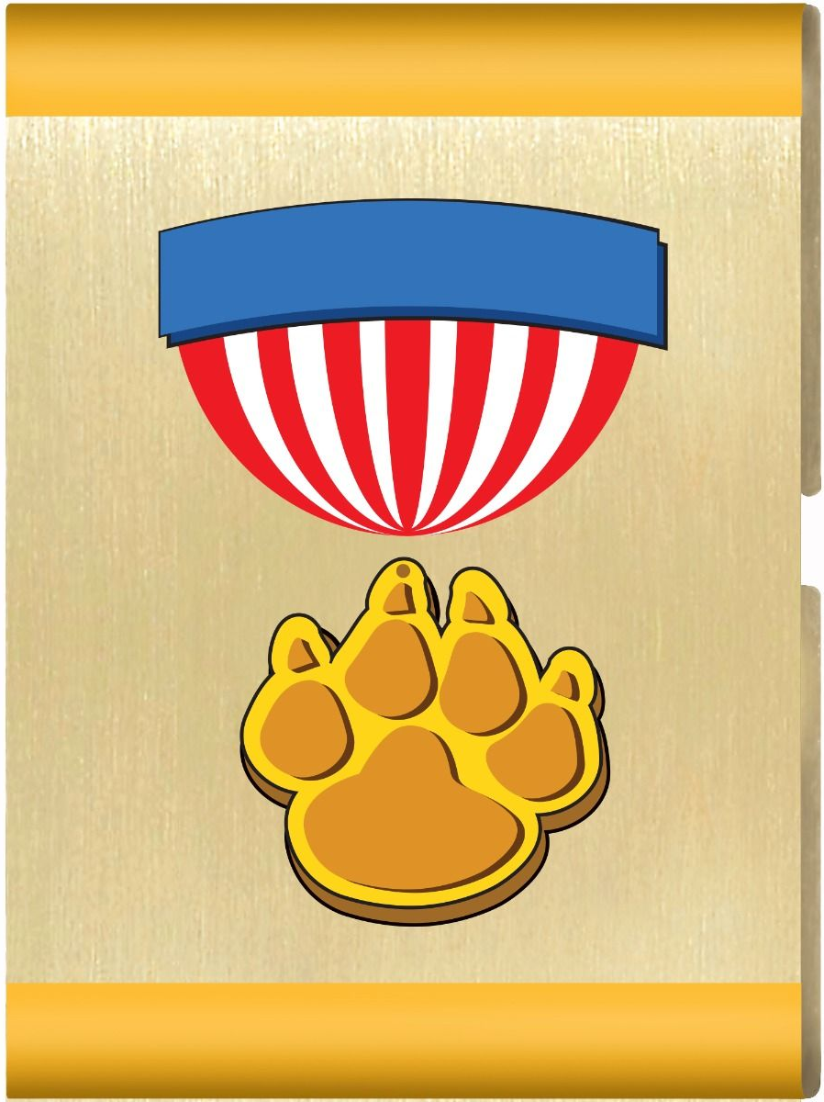
Lion’s Honor Adventure
Material List
Parent and Leader Guidebook: pages 28-31
Lion Adventure Book: page 5
- Show the Cub Scout sign. Tell what it means.
- Repeat the Cub Scout motto. Tell what it means.
- Show the Cub Scout salute. Tell what it means.
- Show teamwork and good sportsmanship by playing a game with your den.
- Participate in an outing.

Materials
- Copies of Honor Adventure handout (page 3 below), one per adult
- Copy of Den Meeting Plan (page 2 below), one for leader(s)
- Name tags and Sharpie
- Copies of pack calendar
- Cub Scouts Poster Set with Scout Law, Scout Oath and Den Code of Conduct
(#621086 from Scout Shop)
- Blue tape or something to hang posters on wall

Optional
- Snack and water
- Activities for siblings (e.g., coloring books)

Activity 1: Introduction Game
- Ball

Activity 3: Den Poster
- Poster
- Sharpie – to prewrite message on poster (e.g., Meet the Lions)
- Washable markers

Wrap Up Game
- Colored pencils, crayons or markers
- Few extra copies of Lion Adventure Book page 5 (for those who forget book).

Supplemental Activities (can be sent home if meeting runs long)
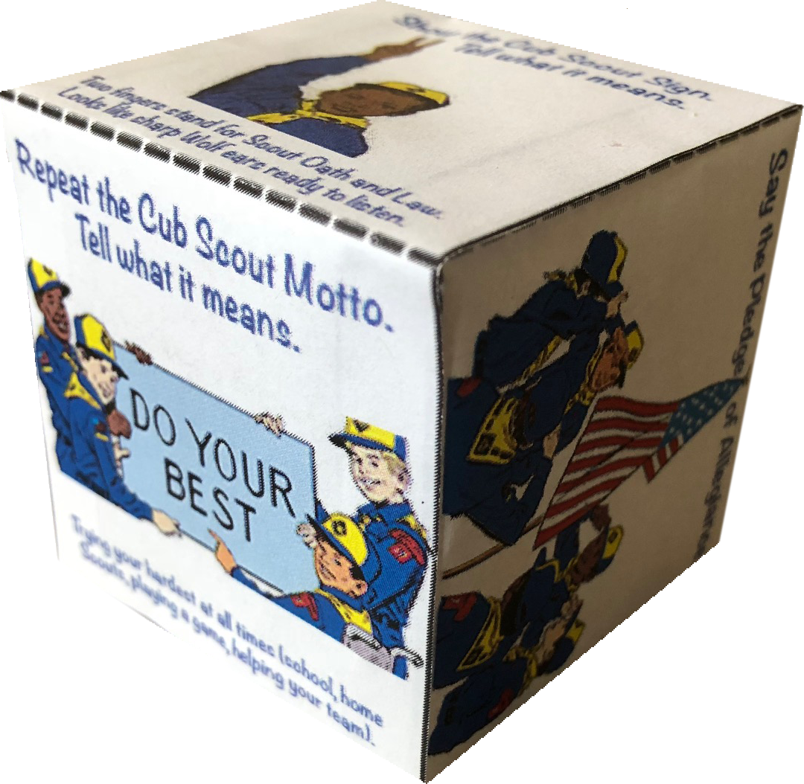
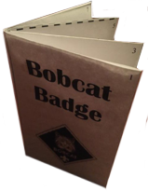
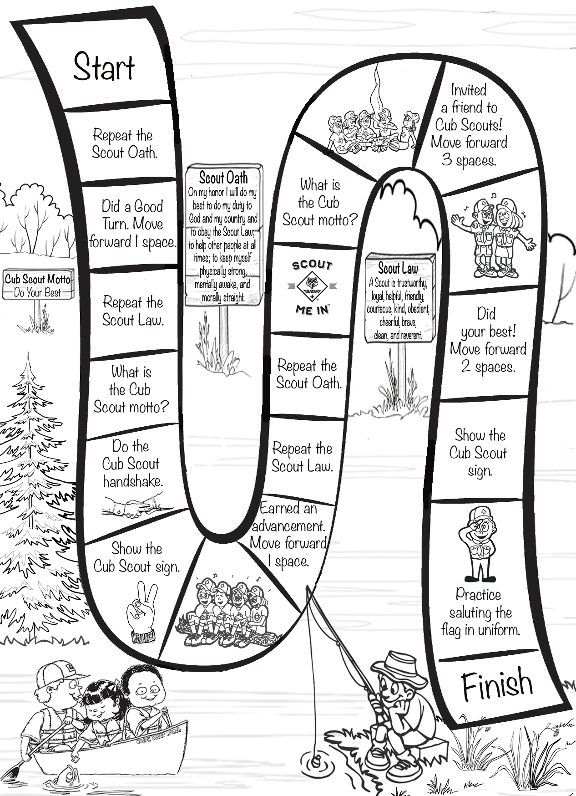
Den Meeting Plan
Lion’s Honor
Parent and Leader Guidebook: pages 28-31
Lion Adventure Book: page 5
- Show the Cub Scout sign. Tell what it means.
- Repeat the Cub Scout motto. Tell what it means.
- Show the Cub Scout salute. Tell what it means.
- Show teamwork and good sportsmanship by playing a game with your den.
- Participate in an outing.

Gathering
- Lion Says game
Opening
- Good conduct candle
- Pledge, Scout Oath, Scout Law
- Sing If You’re a Lion and You Know It (handout)
Talk Time
- Explain rules of behavior. Good conduct candle
- Announcements
- Lion sharing
- Meeting plan (what to expect this meeting)
Activities (page 29)
- Activity 1: Introduction Game
- Activity 2: Salute or Sign Game
- Activity 3: Den Poster
Wrap Up
- Lion Adventure Book, page 5
Closing
- Scout Oath
- Form a circle with everyone putting their right hands in the middle. On count of three, have Scouts raise hands and yell, “Do Your Best!”

Honor Adventure

If You’re a Lion and You Know It
Tune: If You’re Happy and You Know It

If you’re a Lion and you know it, show your claws.
If you’re a Lion and you know it, show your claws.
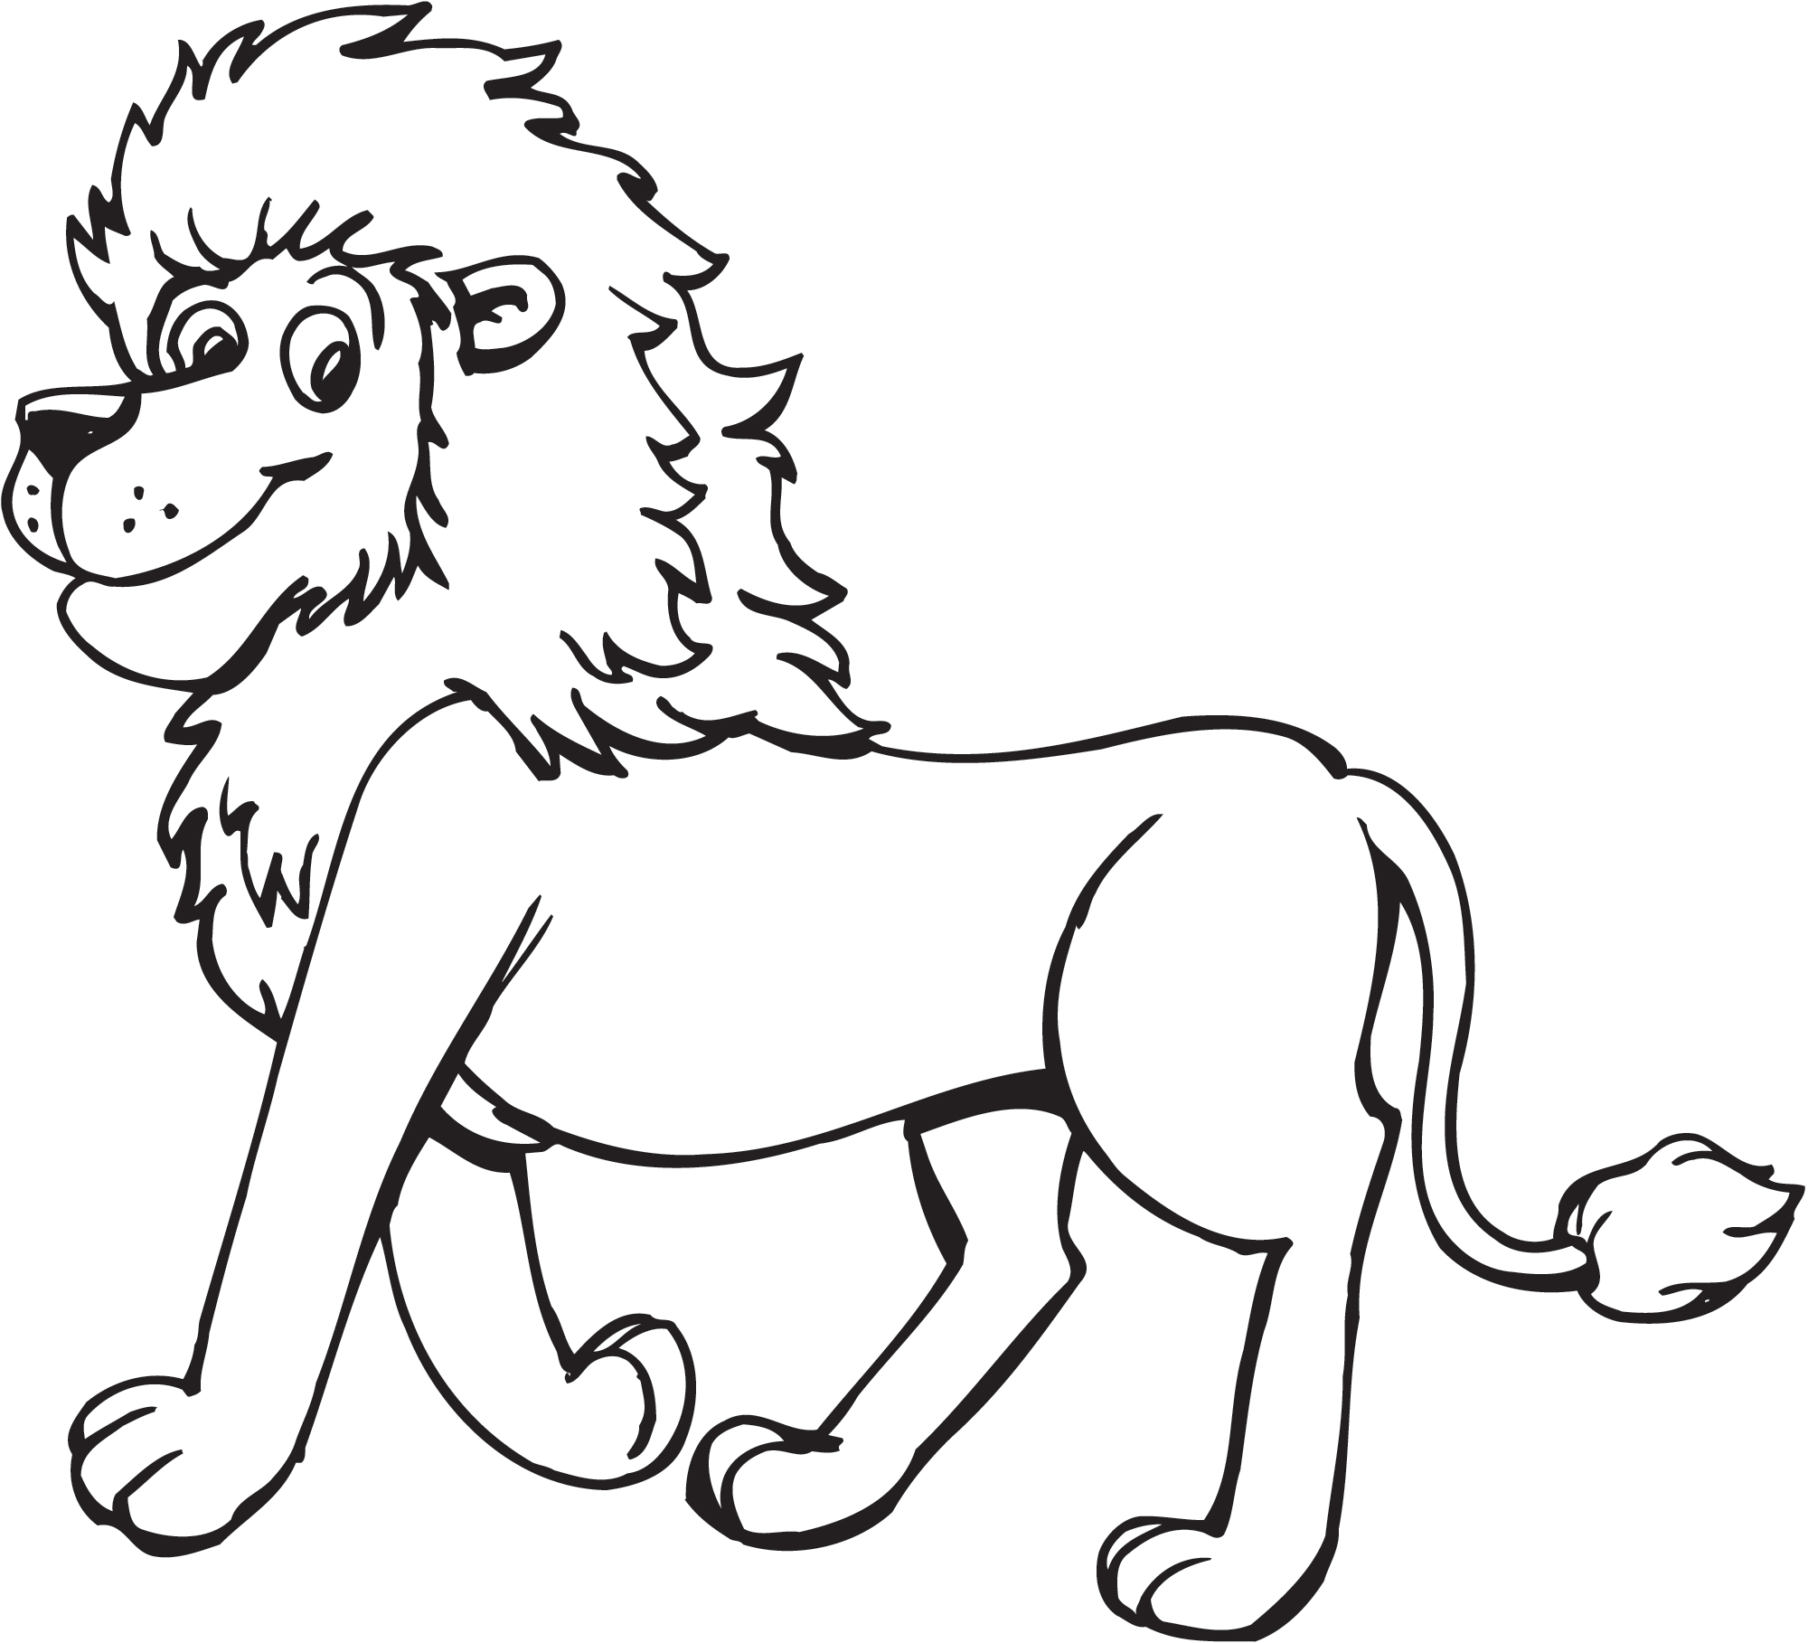
If you’re a Lion and you know it, then your claws will surely show it.
If you’re a Lion and you know it, show your claws.

If you’re a Lion and you know it, show you’re strong.
If you’re a Lion and you know it, show you’re strong.
If you’re a Lion and you know it, then your strength will surely show it.
If you’re a Lion and you know it, show you’re strong.

If you’re a Lion and you know it, give a roar.
If you’re a Lion and you know it, give a roar.
If you’re a Lion and you know it, then roaring will surely show it.
Scout Law
A Scout is trustworthy, loyal, helpful, friendly, courteous, kind, obedient, cheerful, thrifty, brave, clean, reverent.
Scout Oath
On my honor, I will do my best to do my duty to God and my country and to obey the Scout Law; to help other people at all times; to keep myself physically strong, mentally awake, and morally straight.
If you’re a Lion and you know it, give a roar.

If you’re a Lion and you know it, do all three.

Scout Shop
6512 FM 1960 West (at Champion Dr)
Houston, TX 77069
(281) 444-1152
Mon.-Fri.: 10 AM - 7 PM
Sat.: 10 AM - 5 PM
Closed Sunday
www.shac.org/scout-shop#shops

Upcoming Events

Oct 2 Den Meeting

Oct 6 Bobcat Day, 9 am - noon
Orion.shac.org/bobcat-day
Step By Step Christian School

Oct 19-21 Campout at Huntsville State Park, optional

Oct 23 Pack Meeting /
Raingutter Regatta
Pack 72
facebook.com/pack72tomball
pack72tomball.scoutlander.com
Orion District
www.orion.shac.org
facebook.com/orionbsa
Sam Houston Area Council
www.shac.org
facebook.com/shac.bsa
Cub Scout Information
Scout Law
A Scout is…
trustworthy, loyal, helpful, friendly, courteous, kind, obedient, cheerful, thrifty,
brave, clean, and reverent.
Scout Oath
On my honor, I will do my best
To do my duty to God and my country
and to obey the Scout Law; To help other people at all times; To keep myself physically strong,
mentally awake, and morally straight.
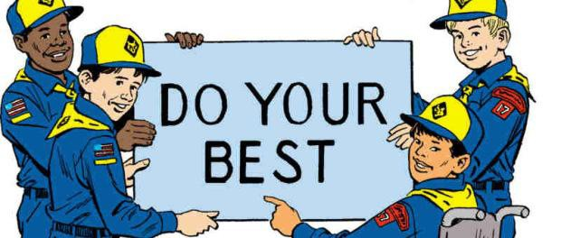
Cub Scout Handshake
Cub Scout Motto
Cub Scout Sign
Cub Scout Salute
Resource: What are the Scout Oath and Scout Law?

Source: www.scouting.org/discover/faq/question10

Scout Oath
On my honor I will do my best to do my duty to God and my country and to obey the Scout Law; to help other people at all times; to keep myself physically strong, mentally awake, and morally straight.

Scout Law
The Scout Law has 12 points. Each is a goal for every Scout. A Scout tries to live up to the Law every day. It is not always easy to do, but a Scout always tries.

A Scout is:
TRUSTWORTHY. Tell the truth and keep promises. People can depend on you.
LOYAL. Show that you care about your family, friends, Scout leaders, school, and country.
HELPFUL. Volunteer to help others without expecting a reward.
FRIENDLY. Be a friend to everyone, even people who are very different from you.
COURTEOUS. Be polite to everyone and always use good manners.
KIND. Treat others as you want to be treated. Never harm or kill any living thing without good reason.
OBEDIENT. Follow the rules of your family, school, and pack. Obey the laws of your community and country.
CHEERFUL. Look for the bright side of life. Cheerfully do tasks that come your way. Try to help others be happy.
THRIFTY. Work to pay your own way. Try not to be wasteful. Use time, food, supplies, and natural resources wisely.
BRAVE. Face difficult situations even when you feel afraid. Do what you think is right despite what others might be doing or saying.
CLEAN. Keep your body and mind fit. Help keep your home and community clean.
REVERENT. Be reverent toward God. Be faithful in your religious duties. Respect the beliefs of others.

Supplemental Activities

Use the supplemental activities as a gathering activity or to send home to help Scouts learn about Cub Scouts.

We will be adding more activities with the goal of being able to send one activity home each month.
- Game Board
  - one copy per Scout
  - one coin per Scout (heads = move 1 space; tails = move 2 spaces)
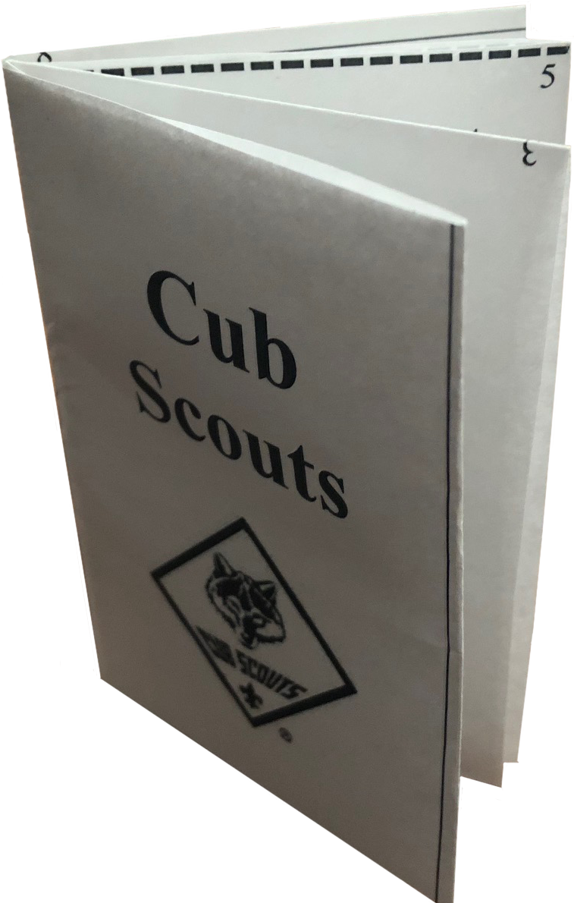
  - game pieces (e.g., buttons)
- Book
- one copy per Scout
- one copy of instructions for leader
- scissors
- sample book already made
- Cube
  - one copy per Scout
  - scissors
  - glue sticks
  - sample cube already made

Cub Scout Book

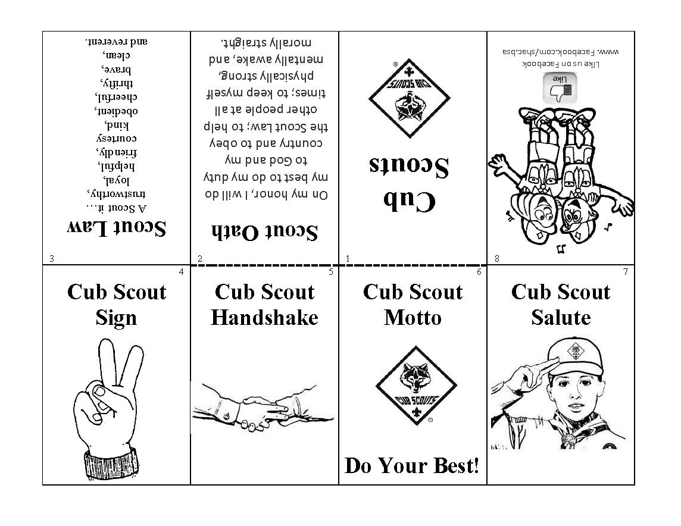
Materials:
- Copy for each Scout, see appendix
- Kid friendly scissors
- Samples

- Cut out the border (outside lines)
- Fold along every line
- Fold in half (top to bottom)
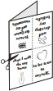
- Cut dotted line
- Open out push center cut apart in diamond, and refold the other way and form into a book.
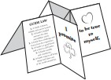

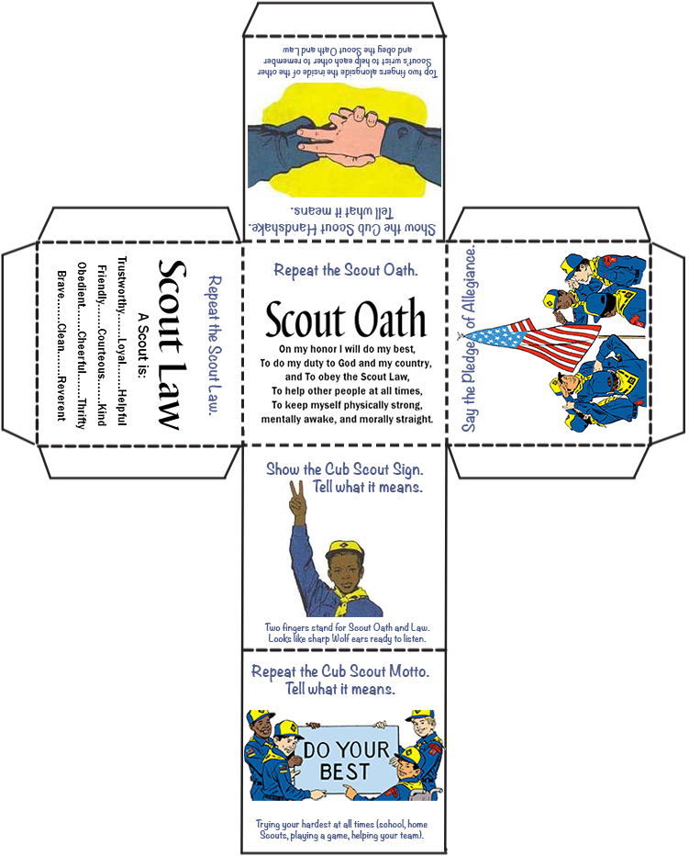
Adults will need to help make the cube.
Cut solid lines and bend dashed lines.
Materials:
- Copy for each Scout
- Kid friendly scissors
- Glue sticks
- Sample

Ideas

- Cut out the face and glue on poster.
- Have parents trace and cut out their hand shape on red paper.
- Have parents help Lions trace and cut out their hand on orange paper.
- 4. Glue hands on poster in shape of lion mane with child’s hand under Lions hand

Poster Idea

Materials Needed
- Copy of this page
- Poster board
- Glue stick
- Scissors, kid friendly for each Scout
- Pencils
- Marker

